Family Experiments with Living on $2 a Day
Author | Anna
Date | 2007-12-03 14:52:37
Categories | Articles Cambodia 1993-2016 Stories
Many of our neighbours lives on less than $2 a day. After 12 months living in a poor Cambodian community we have observed lots of the realities of poverty - ill health, exploitation, malnutrition, lack of opportunities for education and employment etc. At times we also question the ways in which people around us use their limited resources.
But would we be any different? What is it really like to live from day to day? Neighbourhood girls working in garment factories bring home $50-$70 a month, often supporting 3-4 people. Labourers get $2.50 a day with no guarantee of daily employment.
With these thoughts and many more, we set ourselves a challenge: for our family to live on $200 for one month. To put this into perspective, after we paid our rent ($50) and a handful of other fixed expenses we had $2 per day for food.

Budget making, budget breaking
Our supply of western food (weetbix and peanut butter) ran out after the first week. Western supermarkets were out of reach (because of fuel to get there and weetbix are $6.50 a box).
Ruth discovered new veggies at the market and was taught how to cook them by neighbours and market sellers. We can now incorporate lotus stalks, swamp spinach and other unnamed green veg into a tasty meal. Our family also gained a new appreciation for our team lunches and dinner invites!
We did manage to eat for $2 a day but a few unbudgeted surprises came up along the way. Our gas bottle ran out ($13), a doctor's visit ($32), and getting the motor bike fixed ($26) - all blew our budget!
Our neighbours would have to borrow from a loan shark charging 200% interest calculated and paid each month. After we'd completed our "challenge month" we felt like a real pressure had been lifted off us.
If it was reality though, we would be starting the next month $67 in debt, which would take months to recover.

Changes we noticed in our own behaviour...
- We were hesitant to invite people to our place and declined attending social events because of the obligatory gift of money or food which we couldn't bring. It was also "tricky" when visitors came over meal times as our hospitality directly affected how much we ourselves had to eat. We spent a lot more time around home.
- Going out meant transport costs, and food out was too expensive (a coffee out at a western place is $1-3. Even at a local place it's 40c). We had to reduce petrol usage and didn't use mototaxis.
- We "made do" a lot more rather than replacing older items. "Non urgent but sensible" things to do were put off until later. We felt a loss of autonomy and indebtedness when friends invited us out, and paid for us. As a couple we talked A LOT more about money, reviewing expenditure each day.
- There was little room for luxuries without sacrificing something else, and some days it was harder to give to beggars at the market.
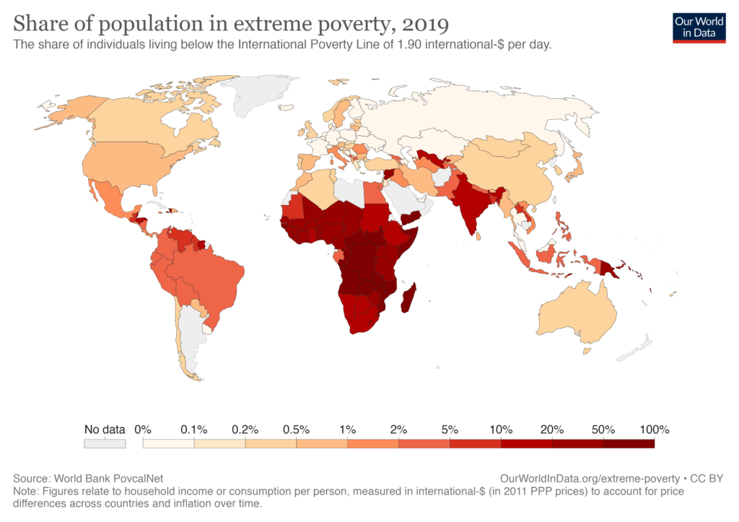
Proportion of population living in extreme poverty, by country.

Some of the things we learnt...
- The poor pay more for food (they buy in small amounts).
- Electricity also costs more as there's middle-men involved.
- Low cost foods often don't have high nutritional value and buying less meat is an easy way to save a bit.
- There's little room to save for "emergencies" or longer-term costs. "Emergencies" happen often and can be in the form of hospital bills, neighbourhood weddings or needing to replace items.
- In fact, in our trial, unbudgeted emergencies were 30% of our total costs.
- People's generosity with food and other daily items was enormously appreciated.
- The choice between food, education costs and healthcare is a day by day reality. It's a different thing to share with others when you are feeling pressured yourselves. We felt constrained and frustrated in not being able to express this part of our personality in the way that were used to.
While money doesn't buy freedom, poverty certainly robs people of it. Living on $2 a day seems like it can be done...
But is just surviving enough?
Or are we created for something more?
Update on the Author (2022): Ruth and Dave are still in Cambodia, with their two kids. Ruth is helping the Cambodian government develop their speech therapy program. Dave runs the JusTees social enterprise ethically making T-shirts with justice-oriented slogans.

Metadata
zn_meta_elements | Array
dsq_thread_id | 2128270975
zn_zn_disable_subheader | no
zn_page_layout | default
zn_sidebar_select | default
zn_show_social | default
zn_subheader_style | zn_def_header_style
zn-custom-layout | 0

