Exciting Learning Opportunity - MA in Transformational Urban Leadership
Author | Admin
Date | 2021-07-16 02:27:13
Categories | Events Past Events

APPLY NOW! CLOSING SOON
Our friends at the William Carey International University are now taking applications for their exciting and challenging M.A. in Transformational Urban Leadership (MATUL). Applications are open until August 15.
This course offers a learning opportunity where you can be:

ACTION-BASED
In this program, simply absorbing information in the classroom isn't enough. What you study in the morning you'll find yourself using that afternoon.

MENTORSHIP-DRIVEN
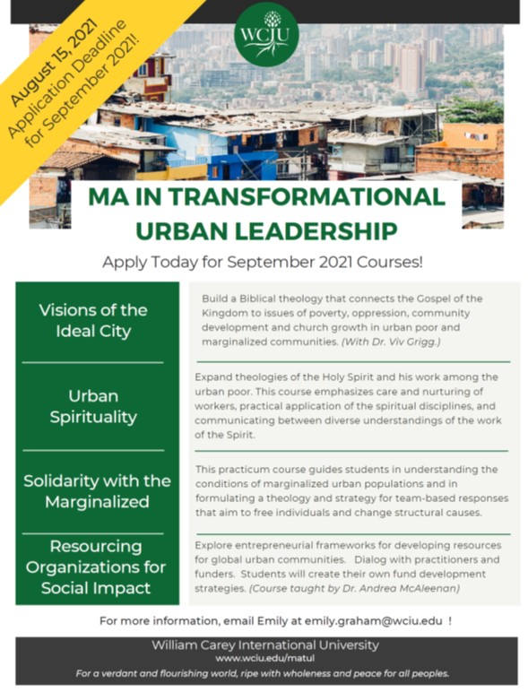
Be mentored by experienced professors and learn the ropes from movement leaders at NGOs and churches.

SERVE THE MARGINALIZED
Your research project won't be theoretical; it will actually help people in dire situations like refugee camps, sex trafficking, and impoverished communities.

LIVE & WORK IN URBAN CONTEXTS
Live and work shoulder-to-shoulder with local leaders in an informal urban settlement.
For more information check the course web-page here, or download the flyer.

Metadata
zn_page_layout | default
zn_sidebar_select | default
zn_show_social | default
zn_zn_disable_subheader
zn_subheader_style | zn_def_header_style
zn-custom-layout | 0

