Drone Strikes: A Terrifying Anti-Terrorism Strategy
Author | Jason Porterfield
Date | 2013-04-28 19:39:09
Categories | Articles
The following reflection was written by two Servants missionaries living in South Asia. For more information on Servants' commitment to follow Jesus' teaching on nonviolent love, see our Statement of Belief & Action by clicking here.
We're writing about this because it seems that beyond the peripheral vision of many Americans, a quiet and ghastly drama is unfolding. For those who are there, of course, the chaos and horror are anything but quiet. But it's not being talked about much in the news, in churches, or anywhere else, for that matter-- but it's something that has been on our hearts for a long time.
We firmly believe that this is an issue that everyone should be able to agree on, regardless of our political or religious persuasions. Both political parties have supported (and expanded) the drone program, but the implications of it are so anti-human that this continuing phenomenon demands the attention-- and the resistance-- of people of compassion. With that goal of stirring compassionate people (and especially followers of Jesus) to action, A. and T. have co-authored this post to look into the human cost of drones, as well as to examine the question of whether this "anti-terrorism" strategy might actually be increasing the risk of terrorism in the United States and around the world.
A couple of months ago, we read an interesting Kindle Single called Aftershock: The Blast That Shook Psycho Platoon(download it for free here) about some of the struggles US soldiers face as they come back from either Afghanistan or Iraq. It talks about the effects of two conditions: post-traumatic stress disorder (PSTD) and mild traumatic brain injury. Aftershockfollows the lives of one platoon that experienced a rocket attack while they were in their barracks at a main base in Iraq. The rocket barely missed their building, and fortunately, only one of the men experienced minor physical injuries from shrapnel. Unfortunately, all of the men experienced some psychological injuries from the distress of a near-death experience and from the blast waves emanating from the rocket. Research is showing that the explosions of these bombs, land mines, and rockets can rattle the brain so much that the end result is like a concussion. Concussions are dangerous enough for football players or other people who suffer accidental head trauma, but the Army’s researchers are finding that concussions are even more severe for soldiers since usually the concussions are sustained in the middle of combat when a flood of chemicals like adrenaline are surging through the brain.
Concussions are strange and unpredictable injuries: some people experience no long-term effects from them at all, while others experience headaches, memory loss and other life-altering symptoms. When these brain-altering injuries occur during traumatic events-- like losing friends and fighting for your life in battle-- they can be compounded by post-traumatic stress disorder (PTSD). Over the past few years, the combination of those two conditions has manifested in many (but certainly not all) returning war veterans as an inability to adjust to civilian life, irrationally violent behavior, and suicide (the VA estimates that18 U.S. war veterans commit suicide every day).
While the effects of bombs on soldiers is concerning enough, it’s even scarier to think about the effects of collective PTSD and serious brain injury on the millions of civilians in these war zones. Under Obama’s administration (the same Obama who won a Nobel PEACE prize), the number of drone attacks in Pakistan and Middle Eastern countries like Yemen has sky rocketed: both the CIA and military both are using these un-manned aircraft to kill whomever they wish from a safe distance.

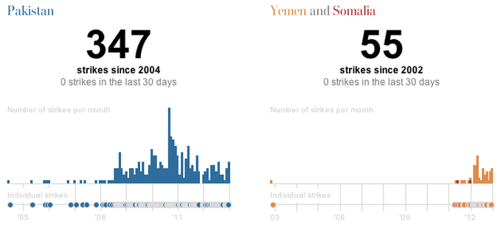

The psychological impact of unpredictable, repeated drone attacks on a civilian population is huge-- it creates a sense of unending, inescapable terror. In addition to targeting individuals who make it onto a “kill list” based on CIA intelligence, there are certain “signature” behaviors or patterns of movement which can cause a person to be targeted by a drone even if there is no prior evidence of terrorist activity. For example, there have been several instances in Pakistan where some men the government had labeled as insurgents were killed in a drone attack, and drones later returned to attack the people who gathered to attend the men’s funeral. Presumably family, friends, and neighbors who happened to know the men showed up at the funeral and were killed just for knowing someone on the CIA’s kill list... often, just being a male of military age is enough to justify your execution (after the fact) as a possible insurgent. Not only that, but so-called "double tap" drone strikes have also frequently targeted people who rush to rescue those injured in an initial attack. The drone attacks are like drive by shootings, just more high-tech. People who happen to know the insurgents (and have no choice in how they are involved), innocent neighbors, and even those who try to rescue the injured after an attack can all become victims of this terrifying anti-terror strategy which asks no questions, hears no witnesses, and executes before there is any chance for legal defense.

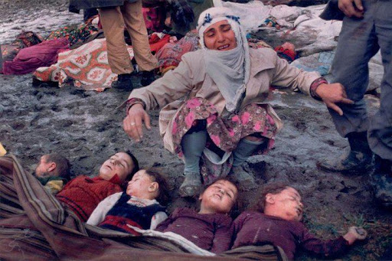
Some collateral damage.

If being in proximity to a bomb blast-- like a drone missile-- can have disastrous effects on the brain and can create PTSD, then isn’t it reasonable to think then that an innocent Afghan, Yemeni, or Pakistani teenager who survives one or multiple drone attacks because they happened to live in the same village as a targeted insurgent might suffer the kind of brain damage and PTSD that would lead him to act violently and irrationally without regard for his own life as he tries to cope with the trauma? Might these traumatized and grief-stricken youth who have lost family and friends to American drone strikes be especially vulnerable to the sales pitches of Al-Qaeda-type recruitment that promises justice and revenge for what they have suffered? As a strategy for decreasing the risk of terrorism on U.S. soil, the use of drones is self-defeating. Not only does it create more enemies for the United States by tarnishing the country’s image abroad and boosting Al-Qaeda’s recruitment, it also sets a dangerous precedent for other nations to follow. Will the world become a safer or more dangerous place if nations like Iran, North Korea, China, and others follow the example of the world’s leading superpower by using drones to carry out extrajudicial killings inside the territory of other sovereign nations with whom they are not even at war? By the low standards we have set thus far, Iran theoretically has the right to strike Israel with drones (which they are acquiring) in the name of national security, and China is entitled to use drones to kill off the pesky Taiwanese or Tibetan leaders who threaten its regime’s power. I think we can all agree that those are some absurd and terrifying possibilities.

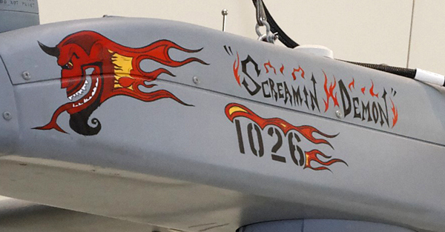
"Screamin' Demon" AAI RQ-7A Shadow drone

At the very least, we as Christians should catch the irony of both President Bush and President Obama using weapons with names like the “Predator” drone, which rains down “Hellfire” missiles, while they simultaneously claim to seek God’s direction in exercising their power as “Christian” leaders. It seems that they’ve either had a miscommunication in prayer or that Jesus has uncharacteristically commanded them to rain down hellfire on their enemies. But hopefully as the Body of Jesus we can sense more than irony-- hopefully the Spirit will open our eyes to see the injustice of murdering innocent people, especially children, in our endless pursuit of greater security for ourselves and our children. Hopefully we sense the danger in ignoring human rights, human lives, domestic and international law in the name of defending our rights. God willing, we will recognize that this violent disregard for the lives of people from a culture and a religion not our own actually cheapens our regard for our own lives and makes a mockery of our supposed devotion to the God who created us all, who imprinted us with His image, who lived and died as one of us, and who declared that He is forever present in the enemy, the outsider, the needy and the rejected ones. Our prayer is that as the community of Jesus, we can take up our cross and find creative ways of practicing the active nonviolent love that Jesus taught us, and that we can find the courage to stand against our society as an example of self-sacrificing love in an age of paranoid retaliation.



Metadata
zn_meta_elements | Array
dsq_thread_id | 1356200661
zn_zn_disable_subheader | no
zn_page_layout | default
zn_sidebar_select | default
zn_show_social | default

