Creative Spaces.
Author | Shannon Mawdsley
Date | 2020-11-10 04:23:51
Categories | Articles God at Work Internships Philippines Stories
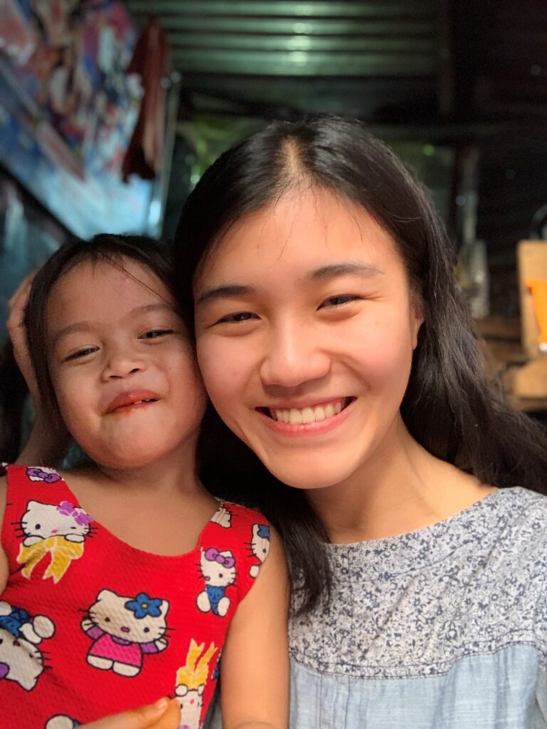
Creating public spaces in slum communities attracted Ariel Bi to the Servants Manila team as she researched for her masters. Here is her story.
My name is Ariel Bi, and I joined the Servants Manila team for a month in January 2020. I am studying landscape architecture and urban planning, and have always been interested in working to help the poor. I chose to join the team in Manila because I wanted to conduct research for my thesis project. This focused on the potential of creating public spaces in Manila’s slum communities. Living in a slum community would give me greater insights than studying any academic materials. I could form meaningful relationships, understand these people’s lifestyles, and discern what their true needs were.
I lived with my host family in a community in a barangay in the northern part of Quezon City. During my first two days in Manila, I joined a retreat that involved the entire community of around sixty people. Even though I didn’t speak a word of the local language, the community was curious about me. As we spent time together I formed many connections. My new friends called me ”Ariella” because “Ariel” is commonly a masculine name in the Philippines. After the retreat I spent my days getting to know the people and building relationships. I also observed the physicality and culture of the community.
Workshops
As well as daily life in the community I went to church on Sundays. I also hosted two workshops during the weekends as I researched creating public spaces in slum communities. One workshop for the children and another for the women. For the first workshop children drew with colored pencils or mold play-doh. The created a garden or play space that they would like next to their house. For the second workshop women shared their experiences living in the community and their dreams and hopes. Through this exercise I noticed a sense of resignation from the participants. There was not much hope for positive changes in their community because they have not experienced them in the past. I realized any successful public space needs to offer people a renewed sense of hope. This happens when positive changes in the community are possible.
Friendship and Treasures
The most memorable time was when I played with the children. I didn’t speak a word of Tagalog, and the children barely spoke English either.
However, I was surprised that verbal communication was not needed for building relationships. They would naturally come to me once they sensed that I was open, friendly, and affectionate with them. They were the sweetest and most friendly children I’ve ever met. I also developed friendships with girls my age where I discovered we shared many similarities.
One afternoon, my friend turned to me with a playful grin and said, “Ariel, I want to show you something”! She then proceeded to retrieve a locked box filled with treasures that she has collected since her childhood. As she showed me her treasures, I had a lot of fond memories. I also collected the same kind of things growing up and put them into special boxes. Reading my friend’s high school journals, I realized that we shared similar emotions, hopes, and dreams. That afternoon became a sacred moment for me. A friend had chosen to let me enter her private world by sharing with me deeply personal things. I realized how much we were alike despite all our social and cultural differences.
Reflections
I deeply enjoyed the sense of community that I never found back home in the States. Back home most of the people I knew lived in apartments or large houses with lots of space between them. I realized that the overly crowded living conditions can cause many problems like bad sanitation and noise pollution. They can also foster social connections and a sense of neighborliness that is absent in the States.
The vast majority of my experience staying with the community was very positive. In the beginning I struggled with the oppressive heat and the way of showering ( just pouring cold water on myself). I adjusted very quickly and deeply enjoyed my day-to-day living in the community.
I did however become uncomfortable with my privilege, which was obvious to everyone despite my Asian identity and clothes. Carrying my iPhone because uncomfortable as no one could afford anything like it. My friends would notice it and comment on how nice it was. I wish I got a different phone to come to Manila. Then I realized most of the community love taking selfies, and my iPhone could produce portraits of excellent quality. Therefore, instead of hiding my phone, I began to use it to take pictures of people. I was able to print the photos and give them as gifts. I learned that instead of being uncomfortable with my “privilege”, I could use what I uniquely had to serve people.
Return to the States
Once I got home to the States I immediately began to notice and evaluate my living conditions and lifestyle. Stepping into my apartment after a month, my first thought was “wow, I live in such a huge space. This is the living space for 15 people in Manila!” Very soon I was deeply aware of how comfortable, even luxurious, my lifestyle was. I grieved over the inequality of this world and the poverty my friends were experiencing.
Work on my thesis project began. “Catalyzing Renewal: Re-imagining Public Spaces for Manila Slum Communities”. I focused on transforming a network of existing open spaces. These would become places that can provide climatic comfort, clean water, and urban farming opportunities. The spaces could also be places where the community can gather and children can play.
I became excited about how the transformation of open spaces can potentially empower people. It can expand their sense of identity and inspire a renewed hope for a better future. I understood that my design proposal, if it were to be executed in reality, would be very ambitious. The slum community lacked funds and there was difficulty in making any major changes there. However, I still hope that one day, there can be pieces from my work that can be realized to create public spaces in slum communities.
My time spent in Manila has been one of the most transformative and invaluable experiences in my life. I gained so much more than contributions to my thesis project. I made friends and established many
meaningful relationships. I understood more about the world and God’s heart for the poor, and more about my calling as a Christian. God is calling me to work in poor urban communities in international settings. I will be graduating from my master's program in May 2021 and don’t yet have a specific vision of the work I will do in the future. I have chosen to focus this final year of studies on international development and social justice for poor urban communities.

Metadata
zn_page_layout | default
zn_sidebar_select | default
zn_show_social | default
zn_zn_disable_subheader
zn_subheader_style | zn_def_header_style
zn-custom-layout | 0
zn_page_builder_status

