Cambodia 1993-2016
Author | Jason Porterfield
Date | 2013-03-19 11:55:22
Categories

SERVANTS CAMBODIA 1993-2016
[Read about the new 2020 team here]
There has been a Servants team in Cambodia since the early 1990s. The decades-long tale includes witnessing God at work in mundane and miraculous ways, experiencing heart break, celebration and tragedy as we shared life with our urban poor neighbours and navigated team life seeking to follow Jesus here.
Here's an introduction to our work we made in 2008.
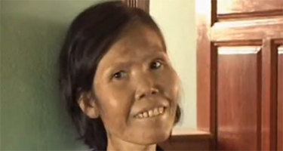
2008 Intro Video
Over the years of involvement in our neighbourhoods, we have deliberately sought to mobilise local church volunteers and community workers. Believing the greatest resource of a community is its people, we look out for compassionate people, plan and dream together and where appropriate provide training, encouragement and seed resources to together bring Jesus’ love to their poor neighbours. It’s been encouraging for us to see the growing passion, skills and confidence of those emerging leaders.At times these initiatives have grown into both formal and informal development projects. Initial Servants projects included Health care, nutrition and sanitation, support for kids with disabilities, community drug rehabilitation, family based orphan care, microfinance and savings groups and Home based AIDS care.Two local NGO’s developed from Servants projects within the first 10 years. CODO (Community Orientated Community Development) continues to work in poor communities in preschool, health and development projects. TASK (Supporting the health and development of the poor) organisation was the localisation of Servants project work in 2004, projects closed in 2011.
During 2009 – 2016 the Servants team was involved in youth mentoring, preschool development and informal education classes (homework clubs) within the neighbourhoods we lived and strengthening networks amongst faith based and non-faith based human rights and justice seeking groups. From this grew 3 community preschools and 70 children attending homework club with a network of young people serving their communities as teachers. 4 years after finishing, many of the leaders continue to volunteer their time to support their neighbours education and a local churches continue to run preschool classes. As these teachers start to have their own children we are excited to see them incorporating play, reading and literacy support into their parenting, this in turn supports their community.
Here's a TV special made about our work in 2013.
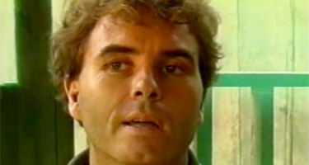
2013 TV Special
Justees screen printing social enterprise began in 2009 as a meeting point of 2 passions – promoting justice and supporting young Cambodian men to pursue an education. Men in Cambodia are a crucial target group as many issues within families and communities often are caused by men, such as domestic violence, alcoholism, gambling, and unemployment. The program intends to work with the young men until they finish their study providing discipleship and mentoring with the goal to have positive impacts on their family and break poverty cycle. Many of the men Justees employs have a past history of drug abuse, and all of our men are from urban poor families. To learn more about this project and see the great designs you can buy online please visit www.justees.org.
The Servants team closed down in 2016. Here's a reflection we put together in 2018.
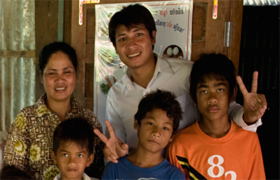
2018 Reflection
Although the Servants Cambodia team formally closed in 2016. A number of ex-Servants team continue to live and serve in Cambodia with the following organisations.
Alongsiders International: mobilizes and equips young Christians in the developing world to walk alongside those who walk alone: orphans and vulnerable young people.

OIC Cambodia: Cambodian NGO seeking to establish speech therapy as a profession in Cambodia.

Justees : T shirt printing Social Enterprise business.

Manna for Life: Engaging and living in Cambodian communities to empower and transform.


Metadata
zn_meta_elements | Array
dsq_thread_id
zn_page_title_show | no
zn_page_title
zn_page_subtitle
zn_zn_disable_subheader | no
zn_page_layout | default
zn_sidebar_select | default
zn_page_builder_layout | default
zn_page_builder_status | enabled
zn_page_builder_els | Array
zn_subheader_style | zn_def_header_style
zn_page_override_boxed_layout | def
zn-custom-layout | 0
show_header
show_footer
zn_page_custom_css
zn_page_custom_js

