Cambodia Team Update
Author | C Dee
Date | 2021-09-09 04:08:03
Categories | Cambodia COVID-19 Pandemic Events Past Events
Join us on Thursday 23rd September to meet three amazing Filipinas, who committed themselves in early 2019 to relocating to Phnom Penh to serve among the urban poor there. For months they prayed, discussed and dreamed, together with Servants mentors. Later they resigned from their jobs and raised support, ready to move. In early 2020, weeks before their intended departure, the Coronavirus pandemic re-wrote their plans.
Unable to move to Cambodia, the team have made significant contributions in a squatter neighbourhood in Manila, while they continue team building and preparation. It's been a journey of much learning and many adjustments.
You are warmly invited to meet the team (online by Zoom), for an update on their preparations and adjusted plans, and to hear the latest stories about their work in NIA community.

Thursday 23rd Sept, 2:00pm Manila time
(7:00am London, 4:00pm Brisbane, 6pm NZ, 11pm US West Coast - click here to see other time zones)
To join the meeting please write to events[at]servantsasia.org and Mark will email you the link.
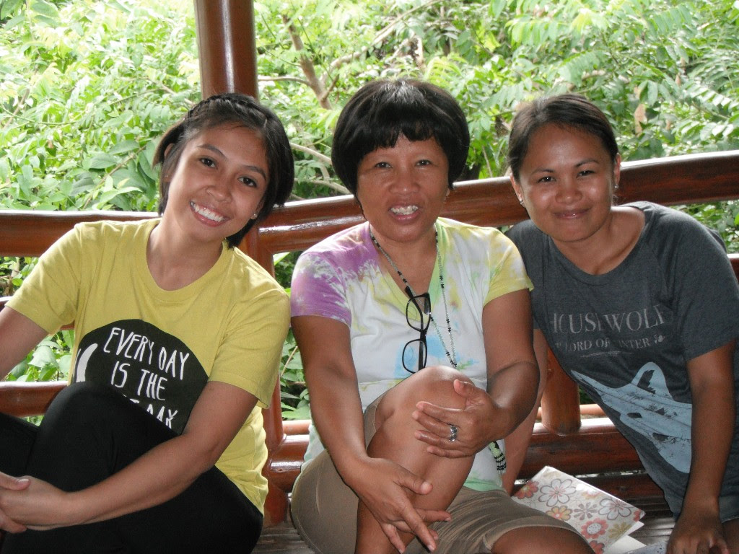
(L-R) Eunice, Carol and Myra
Read more on their team page, and join us on Thursday 23rd to ask your questions, hear stories, see photos and pray for the team.
We hope and pray they will finally reach Phnom Penh in the first half of 2022.

Metadata
zn_page_layout | default
zn_sidebar_select | default
zn_show_social | default
zn_zn_disable_subheader
zn_subheader_style | zn_def_header_style
zn-custom-layout | 0

