Cambodia: April 2022 Team Update
Author | C Dee
Date | 2022-04-24 22:00:16
Categories | Articles Asian Voices Cambodia Philippines
Happy Khmer New Year to Everyone!
May the remembrance of Jesus' death and resurrection continue to give you hope and peace in these challenging times!

Hallelujah!
We finally landed in Phnom Penh. It was a breeze entering Cambodia and tricky coming out of the Philippine immigration. Efren and Becky travelled with us and stayed until April 15.

New Place
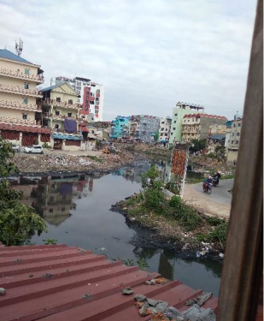
View from our window
We like our new place which has the same feel as NIA. It’s like we never left home. And yes, we have windows with a good view of the outside. Leakhena prayed with us during our first day in the house and introduced us to her mother and relatives. The children from the neighborhood pass by our door and keep saying hello. In buying stuff for the house, owners offered us water and food. We feel the warm welcome of the Khmer people.

Retreat
April 4-6, we joined GMC’s first missionary retreat This is the group that facilitated our entry to Cambodia and will help us in processing our one-year visa. On the last day, we were officially recognized as their missionaries.
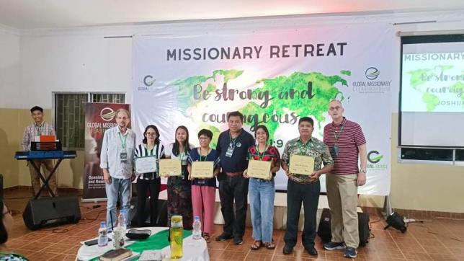

Impressions
Eunice: It is good to be back again and remember the familiar sights. I feel I can belong here.
Myra: I felt that the two weeks field visit (June 2018) was not enough to be acquainted with the place and people here in Cambodia. But now that I’m back, those days (Field Visit) are sufficient to feel that I am in the right place.
Carol: It’s amazing to see how God has made a way for me to be here in Cambodia. I am trusting God for the uncertainties that I am going to face together with Eunice and Myra in this new home.

Praying for and with us
We are thankful for our family, friends, church, and supporters who faithfully journeyed with us.
Please pray for their well-being, and comforting adjustment for our family in the Philippines
We are thankful for the location of our house which is near the language school, hospital, and market.
Please pray for:
- Patience, humility, and perseverance in learning Khmer
- Wisdom and joy as we settle in our new community
- That we may fully embrace this new chapter in our team life
- Extension of our visa. Our visa will expire on April 30.
- Eunice still needs to raise 50% of her support
- Myra to have a computer for her language class.
- Additional team members
We are thankful for Carol’s sister Elaine fully embracing her role as caregiver. Thankful too that her brother’ssurgery last March 31 went well. Please pray for her sister’s health, wisdom, and patience in relating with her brother and mother.
Please continue to pray for Kevin’s health. (Kevin is a former Cambodia team member, who lives and works with his wife Leakhana in Phnom Penh.)
Blessings, Myra, Eunice, and Carol
See other pages on our website to find out more about this team, and steps to joining a team in Asia.

Metadata
zn_page_layout | default
zn_sidebar_select | default
zn_show_social | default
zn_zn_disable_subheader
zn_subheader_style | zn_def_header_style
zn-custom-layout | 0

