Cambodia
Author | Admin
Date | 2019-11-18 02:08:51
Categories

NEW CAMBODIA TEAM 2022

We are very excited that three Filipino women who committed to long term service in Cambodia, have now arrived in Phnom Penh. The Servants Philippines team has been supporting their preparation and formation, and they initially planned to arrive there in April 2020. They have been delayed for two years by Covid-19 restrictions in the Philippines and in Cambodia, and finally landed in Cambodia on 1st April 2022. We hope that this new team of three will be joined by others in the coming year, to establish a diverse (but majority Asian) team of at least five adults.
If God is drawing you to serve alongside these women, among the poor and oppressed of Cambodia, please be in touch!
Other than more team members, this new team also needs people who are committed to pray for them, and support them financially. To find out more about supporting the team, or to pledge a commitment to pray or give, write to psap[at]servantsasia.org.

MEET the TEAM
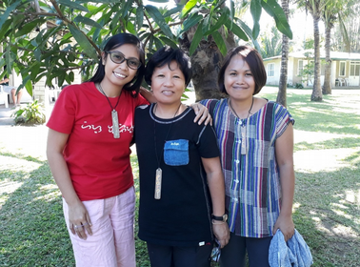
The Team!
We asked team members to explain their vision in 50 words or less, and here’s what they said
Myra: "To become a companion or sojourner with Cambodian people in urban poor communities, so that together we can find God's love and faithfulness in times of grief and joy, hurt and being well, feeling lost and feeling found, and in times of suffering and times of fun."
Eunice: "I want to go to Cambodia to know and experience God's presence in the midst of life with people from urban poor communities. By journeying with them in their sufferings and joys I'd like to find how an Asian might help a fellow Asian to bring hope and the gospel."

EXTENDED TEAM PREPARATION
The two-year delay in plans has called for a lot of adjustments, as Covid struck when they were almost ready to leave. On the upside, it has created much greater opportunity for team building, and working together in a familiar environment before facing the challenges of a new culture and language.
Unable to move to Cambodia, the team has swung into action in Manila, moving into the NIA slum in cooperation with the Living Springs Christian Church there. Some of their involvements in the neighbourhood are:
- KIDS' EDUCATION: With all schools in the Philippines operating online only, and children ordered to stay at home, there has been a great need to support children in their education and well-being. The team have been tutoring neighborhood kids and giving them opportunities for friendship and recreation, as possible under the restrictions.
- FOOD DISTRIBUTION: During the months of May, June and July, they had the opportunity to give 5 kilos of rice to 105 families (scavengers and pedicab drivers), mats, pillows, towels, 1 kilo of rice to 45 families.
- HYGEINE & HAPPINESS: They also distributed 60 hygiene kits, and 52 drawing kits to children. Before distributing the hygiene and drawing kits to the children, they had a one hour health promotion session, encouraging children to stay healthy and discussing how germs are transmitted from one person to another.
- YOUTH CAMP: An interaction between Eunice and a 15 year old boy revealed serious mental health challenges, and prompted the team to organize a camp for ten boys aged 11-21. The camp was held at the Lilok Farm, giving the boys an opportunity to express their feelings through the mood tracker activity and one-on-one time with the facilitators.

NEWSLETTER
The team has begun sending a newsletter with updates and prayer points. If you would like to be added to the mailing list, please write to CMission172[at]gmail.com.

NIA GALLERY
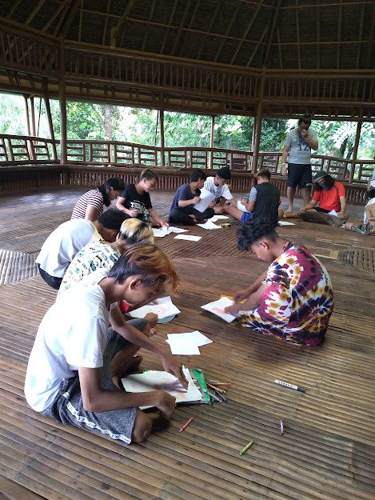
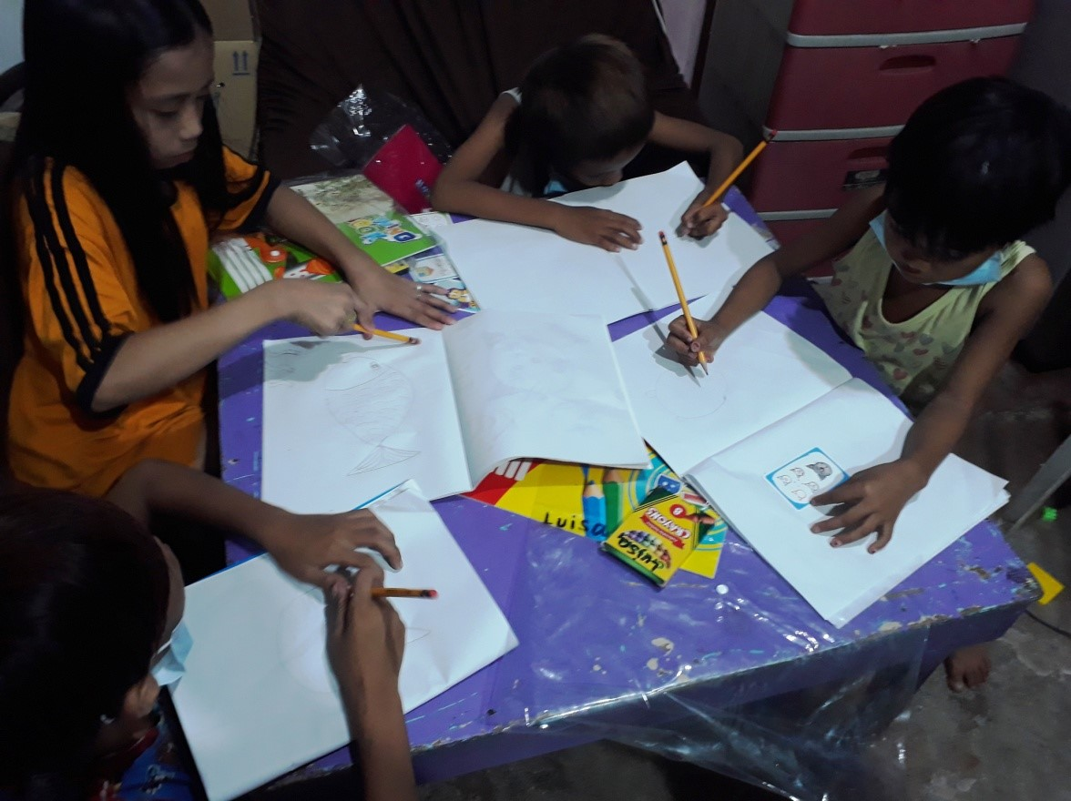
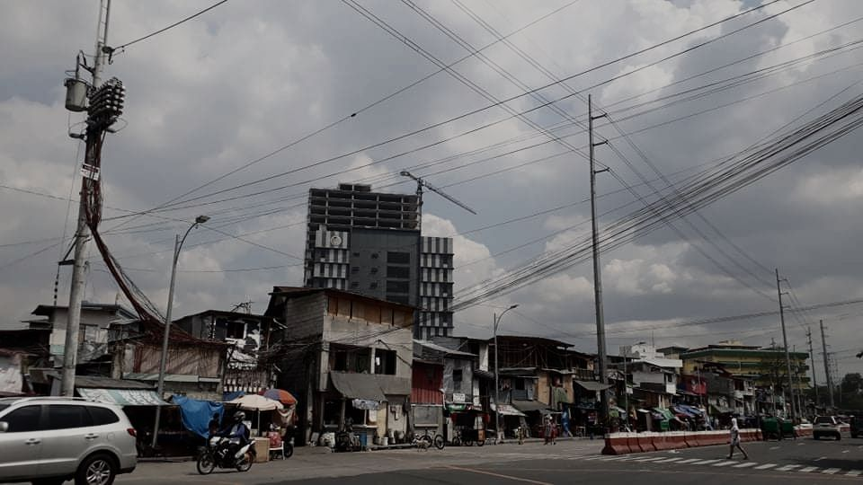
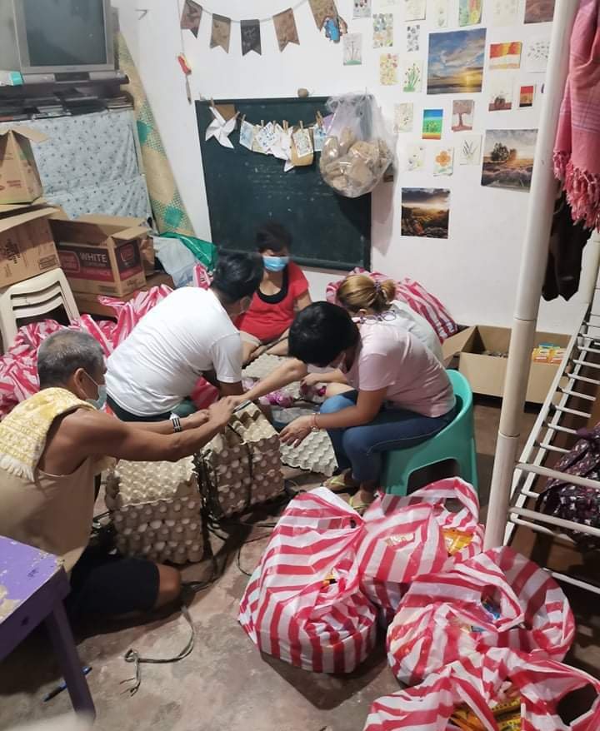
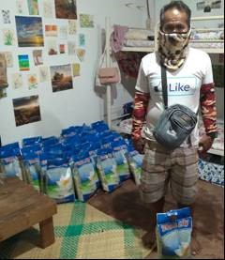
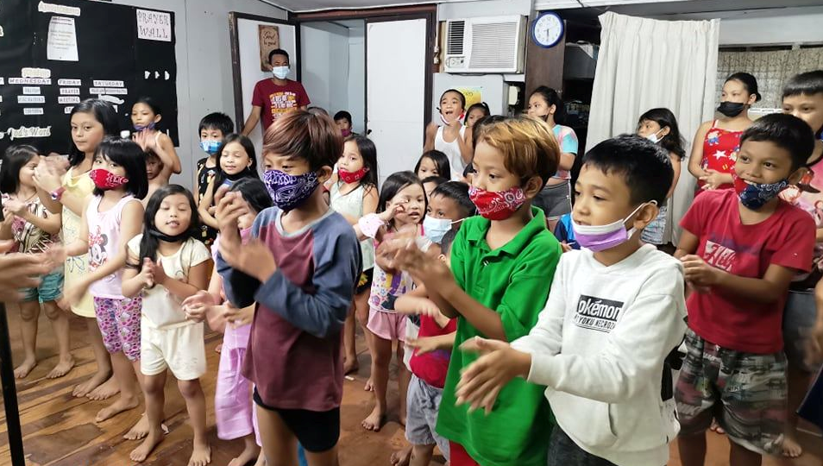

BUDGET PROGRESS
The team is currently raising financial support for once-off expenses of preparation, relocation and getting established (total US$11,274) and ongoing costs of daily living in Phnom Penh (total US$22,095 per year). This budget will be met partly by their own churches (10%), and the remainder by their personal support-raising efforts and by sponsorship through the Philippines Servants team (PSAP). Carol has raised 100% of her personal support target, while Myra and Eunice both still need more personal support to reach their targets. To contribute financially contact the Servants Linking Team in your country, or write to psap[at]servantsasia.org.

BUILDING ON DEEP FOUNDATIONS
Our new team is starting fresh, but building on an amazing legacy of Servants work in Phnom Penh since the early 1990s, when a team of medical professionals were contracted by the government to serve the health needs of people in one district of Phnom Penh. Ever since then, new workers build on the learnings and relationships of earlier workers and community people of peace who have been connected to Servants Cambodia over many years. Read more about past people and ministry in Phnom Penh here.

Metadata
zn_page_layout | default
zn_sidebar_select | default
zn_zn_disable_subheader
zn_subheader_style | zn_def_header_style
zn_page_override_boxed_layout | def
zn_page_title_show | yes
zn_page_title
zn_page_subtitle
zn-custom-layout | 0
zn_page_builder_status

