Bring Your Bayong
Author | Admin
Date | 2021-06-24 18:17:23
Categories | Articles Current Immersion Teams God at Work Philippines Stories
From Tim in Manila
Over the past few months, we have been working on a small livelihood project in partnership with a group of mothers in our community. One of the mothers, “Ate” (older sister) Mani, has been working with these mothers for about a year and has spent a lot of time building friendships with them and supporting their various family situations. We had the idea of starting a livelihood project to provide an extra source of income for these mothers as they mostly work as food vendors and have had trouble selling their goods due to the pandemic and I pitched the idea of making and selling bayóngs.
The bayóng is a traditional Philippine bag typically used when buying food at the wet market. Traditionally, the bag is made by weaving together dried leaves, but there have been newer iterations made out of recycled plastic. When I went back to the US last October, I sold a small batch of bayóngs to a few friends in order to help start up this project and buy the materials. My friends and family were really enthusiastic about supporting the project and were disappointed that I didn’t bring more for them to buy!
Ate Mani, a longtime friend of our team, has been leading this project and organizing her fellow mothers. After learning how to make a bayóng from watching YouTube tutorials, she then taught her husband how to make them and they are now teaching the mothers together. We have also been able to work with another local NGO that is under the Philippine Council of Evangelical Churches. They have experience in starting up livelihood projects and have offered to host workshops for our bayóng project so that the mothers can learn the basics of starting a business.
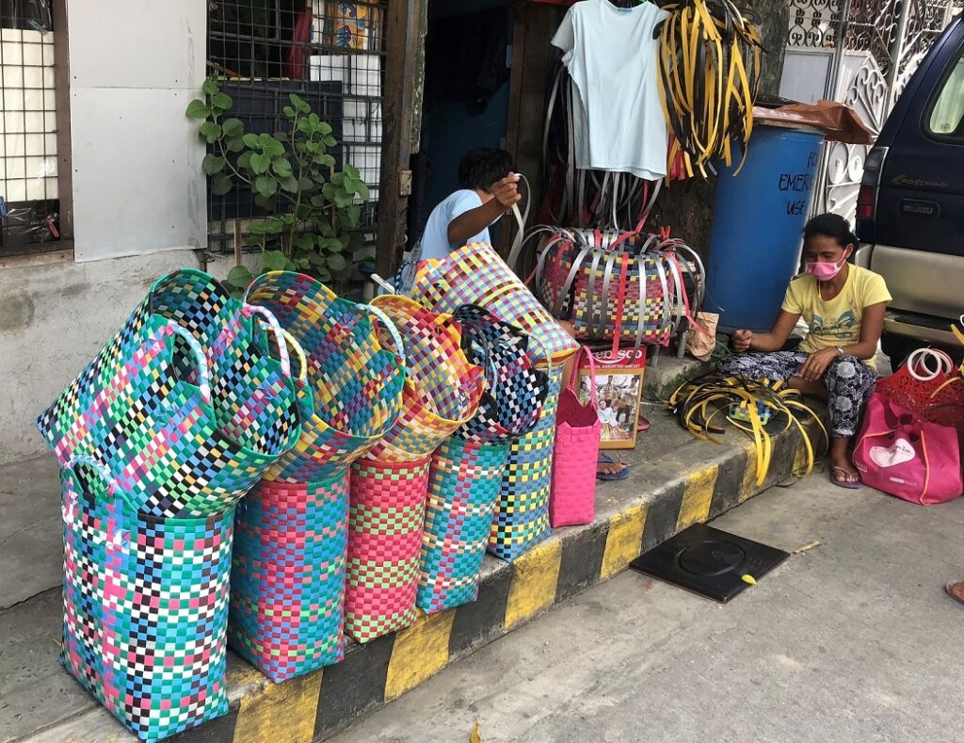
Not only do we hope that the bayóngs can provide some extra income given the financial demands placed on these mothers, who often have to bear most of the responsibility in raising their families, but our goal is to also advocate for anti-plastic practices and promote local Filipino businesses. So, the next time you need a helping hand, make sure to bring your bayong!

Metadata
zn_page_layout | default
zn_sidebar_select | default
zn_show_social | default
zn_zn_disable_subheader
zn_subheader_style | zn_def_header_style
zn-custom-layout | 0

