Bob Ekblad: Sowing Seeds
Author | Jason Porterfield
Date | 2013-05-01 16:20:18
Categories | Articles
The following testimony was recently written by Bob Ekblad. Bob serves as an Elder for Servants and is also the founder of Tierra Nueva (New Earth), an ecumenical ministry located in Burlington, Washington, that seeks to share the Good News of God's liberation in Jesus Christ with migrant farmworkers, jail inmates, Skagit Valley gang members, and those struggling with addiction. To learn more about Tierra Nueva, visit tierra-nueva.org .
The image of the sower in Matthew 13:18ff has always resonated with me, as I have scattered lots of seeds in all sorts of ground: addicted, unbelieving, incarcerated, overworked, and often receptive.
I have witnessed many people receive the Word with joy, drinking it into their thirsty souls. I’ve watched them grow before my eyes. And yet for the countless Bible studies I’ve led and individuals and families I’ve visited, I’ve seen relatively little fruit.
I don’t know what’s happened to most of the people I’ve ministered to as chaplain of Skagit County Jail and in Tierra Nueva’s migrant ministry. Inmates have often gone off to prison, from which they’ve been deported or released to a new life in some place unknown to me. I rarely hear what happens to people who have heard the Word. I’ve clung to texts like Isaiah 55:10-11, which have brought me some comfort.
"For as the rain and the snow come down from heaven, and do not return there without watering the earth, and making it bear and sprout, and furnishing seed to the sower and bread to the eater;So shall my word be which goes forth from my mouth. It shall not return to me empty, without accomplishing what I desire, and without succeeding in the matter for which I sent it."
Isaiah 55:10-11
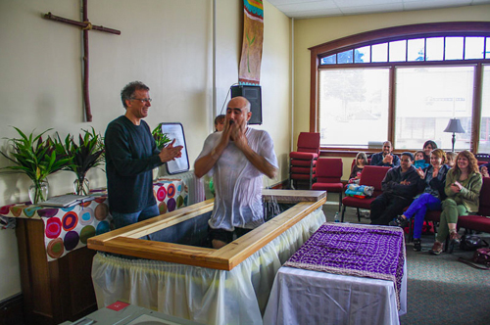Eighteen years ago I met a young man named Julio in Skagit County Jail. At that time he was a scrappy gang banger from Stockton, California, caught up in PCP and crack cocaine addiction and dealing drugs for income. I did one-on-one visits with him while he was in jail, and was increasingly drawn to him. He called me “Pastor Robert”.
Julio and I hit it off, and when he was out of jail I began visiting him and his girlfriend in the apartment from which Julio sold drugs. Julio asked me to read the Bible and to pray with them every week. Our Bible studies were constantly interrupted by customers wanting to buy crack—many of whom I knew from jail Bible studies. Julio would always invite everyone who came by to join in and learn about God. He was a natural evangelist. I loved him.
Julio and his girlfriend had two beautiful daughters together, which added more financial pressures and stress to their relationship. In spite of my best counseling, they broke up. Julio took his daughters to live with his mom in Arizona. He earned a living smuggling illegal immigrants across the Mexican border through the Arizona desert, a skill he'd learned from his stepfather.
He would tell me how his drug addiction was taking a toll on his health. It was hard to keep in contact with him as was constantly changing cell phone numbers. Many times we were out of touch for months. He was always on my heart. My prayers would be answered when he’d call me out of the blue and we’d reconnect and pray together over the phone. His young daughters would sometimes call me saying, “Pastor Robert, can you pray for my dad.”
I really felt my limitations as a pastor with this wily, beloved sheep, and have prayed for him all these years, imagining myself carrying him up and laying him before Jesus. My love for Julio and longing to see him grow drove me closer to Jesus, asking for wisdom, training, more love, more of the Holy Spirit—whatever was needed.
Two weeks ago Julio called me out of the blue. "Pastor Robert, I’m leaving where I’m at and I’m moving back to Washington. I’m ready to surrender to Jesus and to work with you at Tierra Nueva!” He’d been on a Greyhound bus for 2 ½ days already and asked if I could pick him up. He was three hours from Mount Vernon!
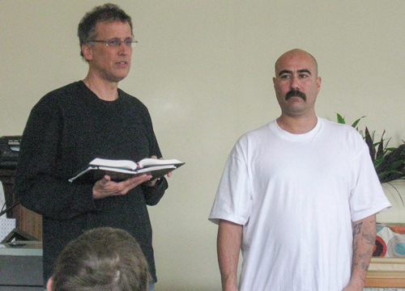Julio moved into our Tierra Nueva building and has become part of our life again. Last Sunday we baptized him. He’s been going out with us on missions to pray for people, and loves it. This has been deeply encouraging to me, and I’m celebrating the realizing of Psalm 126:5-6.
"Those who sow in tears shall reap with joyful shouting. He who goes to and fro weeping, carrying his bag of seed, shall indeed come again with a shout of joy, bringing his sheaves with him."
Psalm 126:5-6
Please pray for Julio as he starts out afresh as Jesus’ disciple and our newest recruit. Pray for his 15 and 17 year-old daughters, who are living on their own now in Mexico, and for their mom who is now in prison. Lift them before the Good Shepherd, Jesus himself. He knows where they are and how to bring them home.

Metadata
zn_meta_elements | Array
dsq_thread_id | 1375804719
zn_zn_disable_subheader | no
zn_page_layout | default
zn_sidebar_select | default
zn_page_builder_layout | default
zn_show_social | default

