Behold the day is coming ...
Author | C Dee
Date | 2022-01-28 05:30:41
Categories | Cambodia Past Events
Join us (by Zoom) on Thursday 17th February, 2pm Manila time, to hear the lastest news and revised plans of our new Cambodia team.
This time two years ago, our new Cambodia team was on track to arrive in Phnom Penh in April 2020. Then Coronavirus became a global pandemic, and all plans changed. It has been a long wait, for the situation to somewhat stabilize in Philippines and Cambodia, and for borders to open. But certainly not a boring or empty wait. Carol, Eunice and Myra have been building their skills and cohesion as a team, while they work in a poor neighbourhood in Manila.
They are working with the Servants Philippines team (PSAP), to finalize plans to relocate and start their lives in Cambodia in the coming months.
You are warmly invited to meet the team (online by Zoom), on Thursday 17th February. We'll hear an update on their preparations and adjusted plans, and the latest stories about their work in NIA community.

Thursday 17th February, 2:00pm Manila time
(6:00am London, 4:00pm Brisbane, 7pm NZ, 10pm on Wed 16th on the US West Coast - click here to see other time zones)
To join the meeting please write to events[at]servantsasia.org and Mark will email you the link.
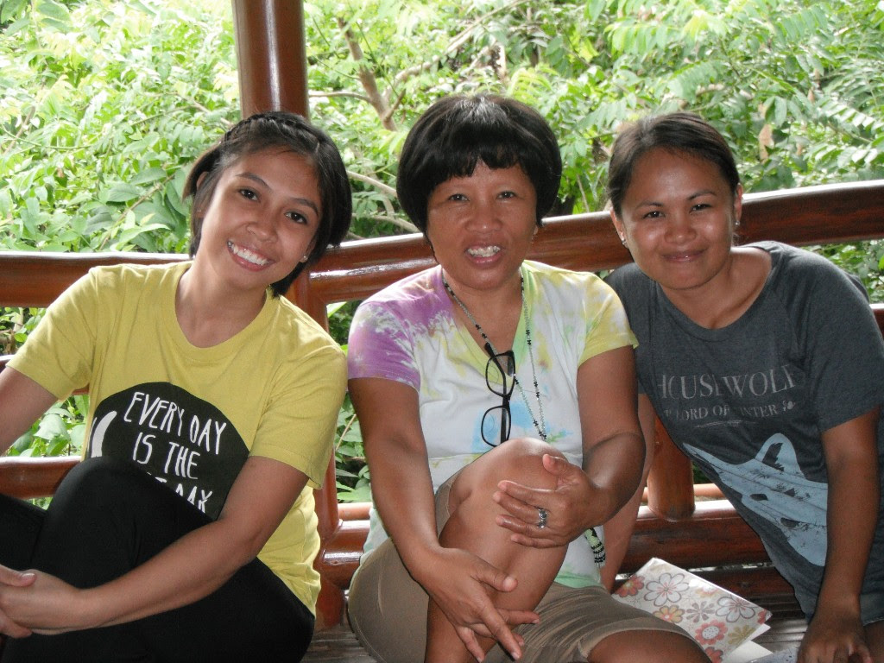
(L-R) Eunice, Carol and Myra
Read more on their team page, and join us on Thursday 17th to ask your questions, hear stories, see photos and pray for the team.

Metadata
zn_page_layout | default
zn_sidebar_select | default
zn_show_social | default
zn_zn_disable_subheader
zn_subheader_style | zn_def_header_style
zn-custom-layout | 0

