Batang Riverside
Author | C Dee
Date | 2020-11-02 20:35:00
Categories | Articles Philippines Stories Videos
“Batang Riverside” means “kid from Riverside”. Riverside is the street that Tim's neighborhood runs off of, and is the colloquial name for his area in Barangay Commonwealth. In the song, the kids sing about how they are a kid from Riverside and that this is what life is like for them there. They also talk about how all of the Philippines is challenged by COVID-19 and how we need to do things like wear masks and practice social distancing so that we don’t spread the virus.
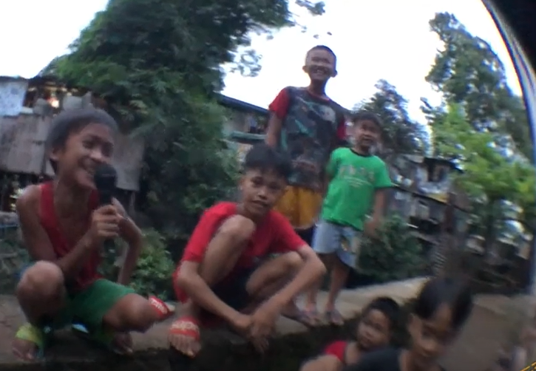
Tim is really proud of all the “Batang Riverside" for working with him to write and record the song (each of the rappers wrote their own verse all by themselves!) and hopes that they will continue to be proud, not just of their individual talents, but of their community. Stay tuned for more music from the kids of Riverside!

Metadata
zn_page_layout | default
zn_sidebar_select | default
zn_show_social | default
zn_zn_disable_subheader
zn_subheader_style | zn_def_header_style
zn-custom-layout | 0
zn_page_builder_status

