As it is in Heaven
Author | C Dee
Date | 2022-09-09 00:19:15
Categories | Events Past Events
Join our friends at The People's Seminary for a thirteen-week Zoom Bible study on Jesus’ missional movement according to the New Testament.

Learn with others

September 30- December 23
13 Sessions: Fridays, 12:00 PM - 1:00 PM (PST)
The New Testament tells the story of God’s sending of his Son, Jesus of Nazareth, who launches a nonviolent liberation movement we are each recruited to join. Jesus proclaimed the Kingdom of God, on earth as in heaven. He taught and demonstrated a kingdom “not of this world,” empowering his disciples with the Holy Spirit to do the same.

Then facilitate Others' learning
These 13 Bible studies will be published in Bob Ekblad’s forthcoming Volume 4 of Guerrilla Bible Studies: Following Jesus: On Earth as in Heaven. In these studies you will find practical guidelines for facilitating liberating Bible studies that mobilize people.
1) September 30. Matthew 28,18-20
2) October 7. Isaiah 42
3) October 14. Luke 4,14-21
4) October 21. Luke 10,1-12
5. October 28 Mark 3,7-15
6. November 4. Mark 6,1-13
7. November 11. Lk 8,40-56
8. November 18. Mark 9,14-32
9. November 25. Mark 16,14-19
10. December 2. Lk 24,36-49; Acts 1,6-8)
11. December 9. Acts 3,1-10
12. December 16. Acts 8,26-40
13. December 23. Acts 10,34-48 (Peter).

Registration Open
Registration Fee:
$50 USD* -LIVE TEACHING WEBINAR
$35 USD* -SELF PACE WEBINAR
*Partial and full scholarships are available in the drop down menu on the registration page
Register here: https://www.peoplesseminary.org/product-page/gw14
If you have any questions or if you need help registering, email Andrew at communications[at]tierra-nueva.org

Other Courses Available
Two other courses are also about to begin, which are also great learning opportunities to boost your understanding and practice of your Christian life and outreach.
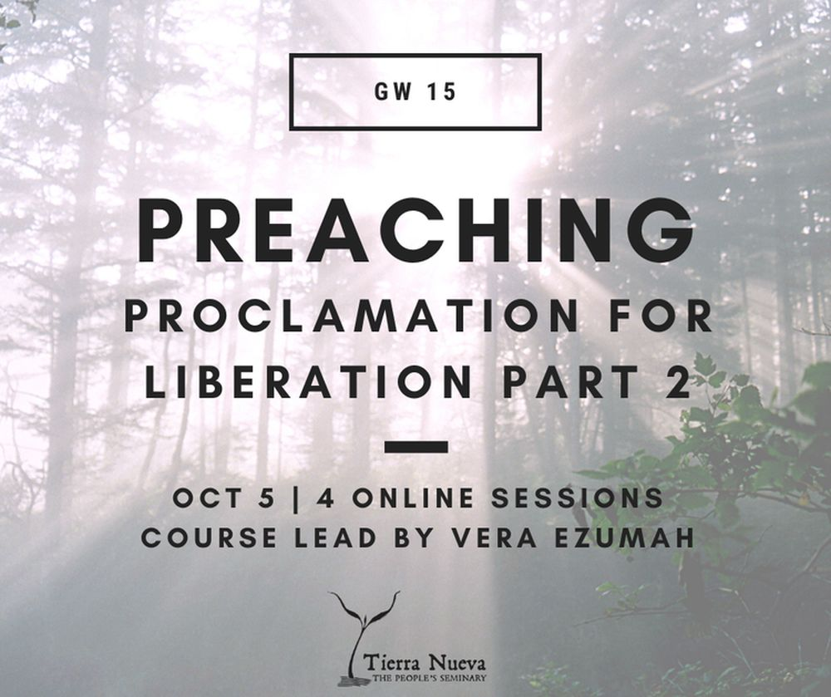

Preaching: Proclamation for liberation
The course aims at helping us understand and appreciate the role of the preacher that we —to some extent, are all called to be. It aims at helping us sharpen our world view; —our knowledge of who we are, and knowledge of God— so as to find the right posture and actively engage in our world.
Join us starting Oct 5, Wednesday 11:30-1:00pm (PDT)
For more information and to register, see the GW15 course page.
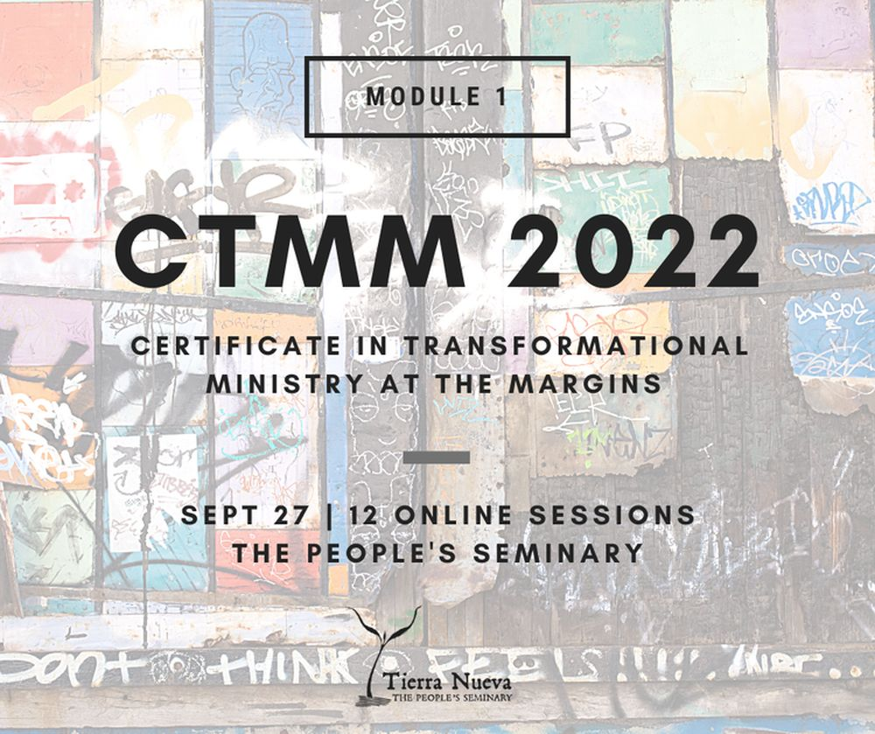

Ministry at the Margins
New CTMM 2022 (Certificate in Transformational Ministry at the Margins) Module 1- Online (live) Certificate Program begins Sep 27
This training is designed to further equip those already serving (or feeling called to pioneer work) amongst poor, under-reached, and marginalized communities.
For more information, or to register, visit the CTMM page.

Metadata
zn_page_layout | default
zn_sidebar_select | default
zn_show_social | default
zn_zn_disable_subheader
zn_subheader_style | zn_def_header_style
zn-custom-layout | 0

