Adjusting to the ‘New Normal’ in the Philippines
Author | Admin
Date | 2021-04-26 20:06:52
Categories | Articles COVID-19 Pandemic Philippines Stories

Contributed by Peter in the Philippines
In the Philippines we started the new year with less strict quarantine rules, but because of rising numbers of new Covid cases we are now back to stricter rules.
The beginning of the long-postponed start of school is a particular challenge for poor families. In the Philippines there are still no face-to-face classes. The students who have a laptop or other media device can join online classes, but for the many others in our neighbourhood who don’t have this possibility it means they have to get the printed module at their school.
Many parents are overwhelmed by this situation. Now along with the household chores and making a living for their family they also have to teach their own kids at home. This is quite an unbearable condition, but as so often seen with the poor, they are far more experienced in adjusting to new Situations. There is often no other choice for the poor and less privileged than to cope and adjust to new struggles.
So we started a tutorial-club where kids can come and get help with their schooling. We also added other kids’ activities for small groups. The kids enjoy learning together and it gives them variety, as children are still not allowed to leave the house.
Sad to say that with the less strict quarantine we experienced at the beginning of the year the EJK (Extra-Judicial Killings) came back in our neighbourhood. In the street where I used to live, a father of five children got killed. The mother told us that three masked men pulled her and the children out of their tiny shack in the middle of the night and then entered and shoot the father. She explained to us that her husband had stopped selling small amounts of drugs a long time ago, but supposedly started again when he lost his job because of the Covid-19 pandemic.
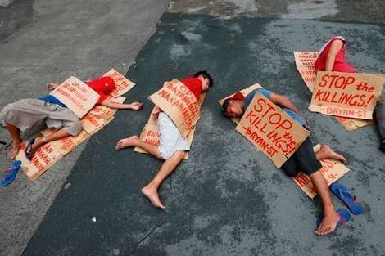
We all know drug use is not good for our health and it’s wrong to sell it to our brothers and sisters. But the same counts for killing people – it’s wrong and it cannot be the solution. It’s not clear if the police are involved in the killing, but it is likely that there will be no investigation.
The War on Drugs is promoted by the Statement "Save the Next Generation: Don’t Harm our Children ". I ask myself: what happens with children who were woken up in the middle of the night and experienced how their father got killed? What kind of message is this for young people in poor communities where these killings usually take place? And finally what does it tell us about the value of life?
Sad to say that many people here feel helpless in the face of these killings. Here, the capability of adjusting to changes in life and coping with new challenges that I so often experience as a cultural strength has its downside, as we should never adjust to injustice.
Some religious and human rights groups have spoken out against these killings. But speaking against the government has become increasingly dangerous, as several human rights activists have been killed in recent years.
Please pray for us here in the Philippines as we learn how to be God’s people in the ‘new normal’.
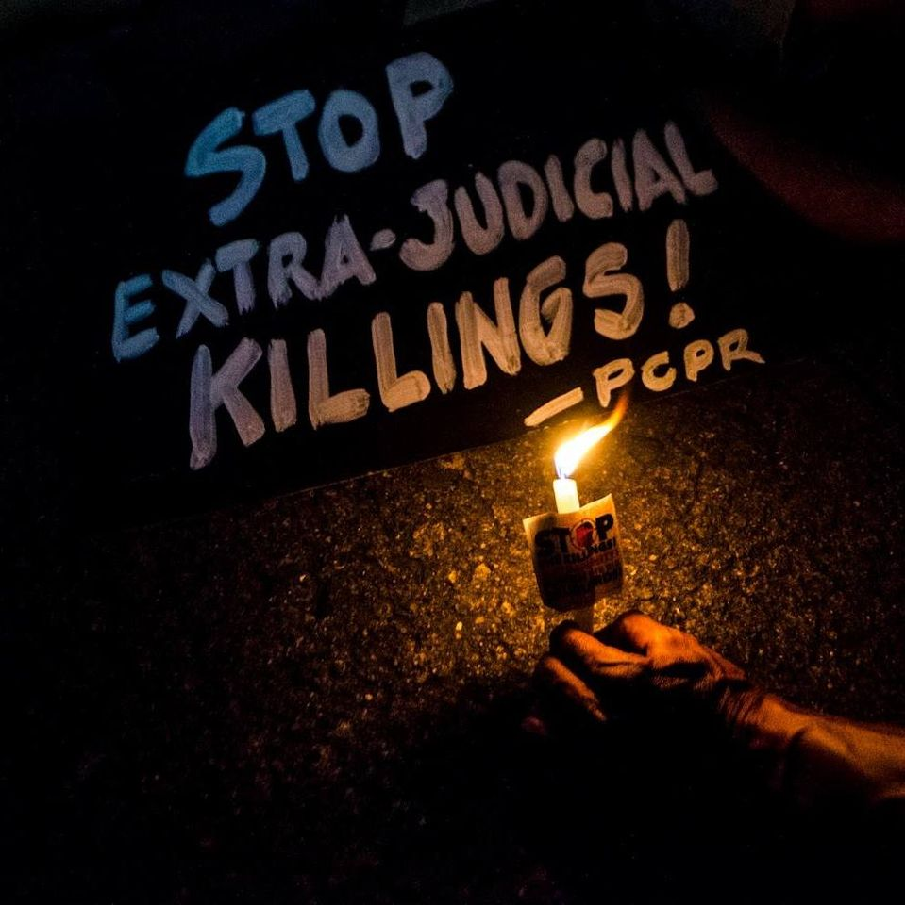

Metadata
zn_page_layout | default
zn_sidebar_select | default
zn_show_social | default
zn_zn_disable_subheader
zn_subheader_style | zn_def_header_style
zn-custom-layout | 0

