A Toilet or Natural Light?
Author | Admin
Date | 2022-09-22 21:25:00
Categories | Articles Current Immersion Teams India Y Stories

(and other decisions on our slum home wish-list)
From Yaqoob* in India
“Sure it’s got no natural light or ventilation, but the water supply is good, and look, you even have your own toilet!”
A potential landlady was showing us a room that was available for rent. We had just moved back to India from Australia and were getting back into our old roles doing community development in a slum. We’d deliberately chosen to live in a slum, so as to be near to our neighbours and understand their problems. Now we were looking for a place to rent.
We’ve done this style of thing - living in slums - for a couple of decades, moving house many times in the process. As we’ve done so, Ruby* and I have developed a pretty clear sense of what’s important to us in our accommodation – and what we can compromise on.
The room we were being shown now, as the landlady pointed out, had the advantage of having its very own toilet. This is not something to be taken for granted, and is indeed a big selling point. Many rental places in a slum don’t have their own toilet, renters instead needing to share a toilet between several families. That can make life pretty tough, especially in the morning ‘rush hour’. In one of our previous rentals there was one toilet for 13 people!
However, for us, the lack of natural light was something we couldn’t compromise on, an independent toilet not withstanding. We’ve found over the years that having natural light is very important to our mental health. Perhaps it it gives us a constant connection of sorts with the natural world outside the slum. If you’re lucky, that natural light may also offer a glimpse of a tree or even birds – also really helpful for our feeling of well-being. Many of our neighbours live in tiny brick rooms, with no natural light, relying solely on the artificial version. I can only imagine how tough living in such places would be, even more so with the frequent power outages – sending occupants scampering for torches and candles.
The room we currently live in has good natural light. It is quite small, with the one and only room about 10 square metres. It also has a small courtyard (about 7 sqm - hence the natural light), a small kitchen (2 sqm) and even a bathroom (1 sqm). Small as it is, it’s been good for Ruby, me and our adult son Yusuf*. However, with Yusuf’s colleague Jeshan* about to arrive back in town and intending to live with us, it’ll be too small for 4 – hence our search for a new place.
After natural light, perhaps the next most important thing for us is not being on the ground floor. Most slums in India are densely packed places with rooms being built one on top of the other. A family who ‘owns’ a piece of land will, if they can, build a 2nd storey to either rent out for a little extra money or, when a son marries and his wife moves in to the family home (as is the custom in of most of India), the new nuclear family has their own space.
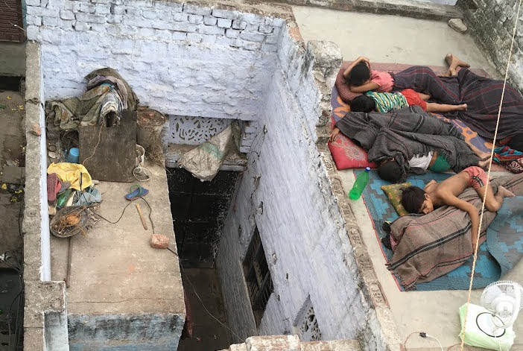
You can sleep on the roof when it's really hot!
Many of our neighbours actually see renting the ground floor as an advantage, being as it is, cooler in the punishing Indian summers. The 2nd storey does indeed keep the sun off the ground floor. However, apart from less natural light, a major disadvantage of the ground floor for us is the lack of privacy. As foreigners we tend to attract a bit of attention, so people can readily poke their head inside a ground floor room just to ‘view’ us. When you like a little privacy, that’s not fun. We find that a 2nd floor place offers just enough disincentive (needing to walk up the steps) that it keeps the number of ‘casual observers’ down.
After natural light and being off the ground floor, a toilet and bathing area is perhaps the next most important factor. This was exactly what our potential new landlady was pointing out as the big selling point of her room. After that, a kitchen of sorts, or at least a place outside the room itself, where we can cook on our gas stove is useful. Many families don’t have this space, so need to cook indoors. This means extra heat in the summer and, if they cook on wood, terrible air pollution – something that kills millions each year.
The particular area of the slum is also important to us, preferably being away from the nosiest parts and thus being a little more peaceful. Finally, we try to consider the landlord. We prefer a landlord who doesn’t own multiple rooms in the slum. For such landlords, our rent would be just another bit of income in an already substantial stream. Instead, we prefer landlords who are struggling financially, and for whom our rent (which is often a little above market rates) will be a significant help.
After considering all these factors, we decided not to take the ‘toilet’ room, but instead to ‘advance’ several months rent to our current landlord (who is not well off), to build another smaller (5sqm) room on top of our existing one. The plan is for Ruby and me to move into that room, with Yusuf and Jeshan occupying our existing larger one. Being top storey, the new room will therefore have good natural light and be two levels away from casual observers. As a bonus, our landlord has also promised to build a toilet on our existing level, taking away the need to share their toilet, as we currently do! With the area also being relatively quiet, the new room actually has the potential to satisfy our entire wish list for our slum house! Let’s see how it turns out!
* Names changed

Metadata
zn_page_layout | default
zn_sidebar_select | default
zn_show_social | default
zn_zn_disable_subheader
zn_subheader_style | zn_def_header_style
zn-custom-layout | 0

