A Surprising Visit
Author | Admin
Date | 2019-12-04 21:58:09
Categories | Articles Philippines Stories
Slowly we walk down the narrow and steep path that leads to our house. Carefully we placed our feet, so as not to step into dog poo or other rubbish and not to slip on the wet path. The air is humid and wet, surely it will rain soon. We hear karaoke, and as is so often true, it doesn't smell so good here.
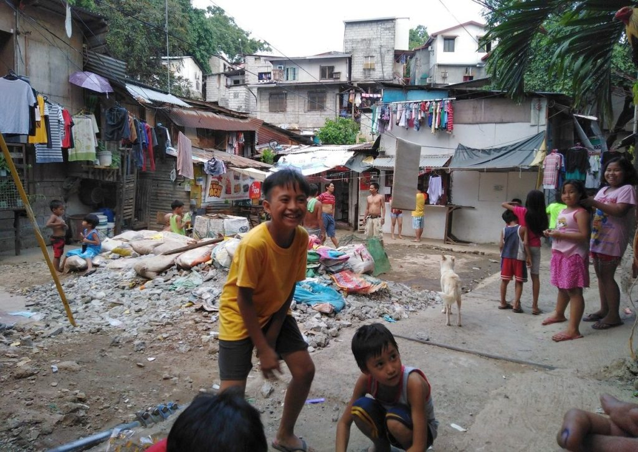
The Street
Many children and other neighbors greet us, but are a bit shy of our guests.
"So this is where you live?"
"Yes we are right there, the house with the blue door is ours."
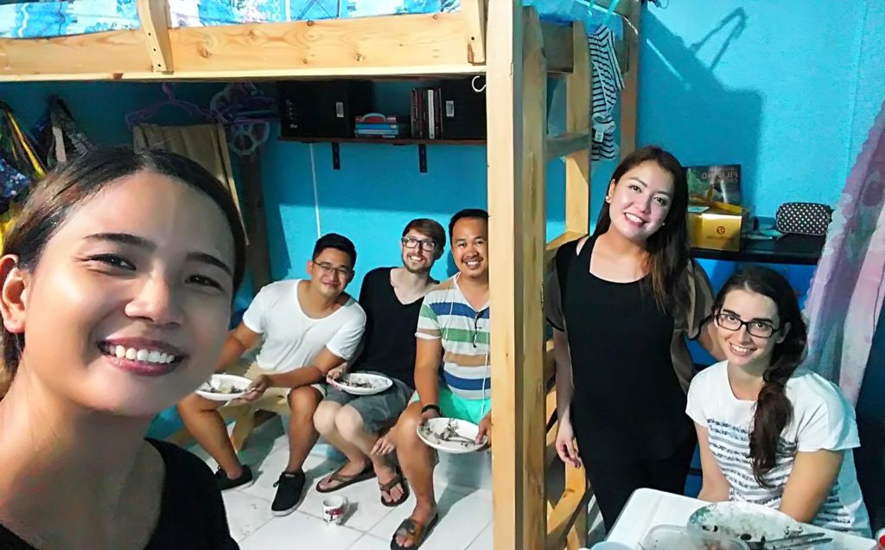
Our room
Once inside the house the questions go on: "You have no air conditioning?” “And you just take a shower in the little toilet room?" "And you just bought the food here on the street corner?" We see into surprised, but also very curious faces. Our visitors are not from Germany or America, they are our Filipino friends from the "Church so Blessed".
During my first missionary stay as a staff member of a drug rehabilitation center in Manila, I made friends in the "Church so Blessed", a middle-class Filipino church. Churches in the Philippines are usually separated by social status. There are churches in the slum (loud, hot, packed with people...), churches that are almost on their way to the middle class (loud, but with air conditioning) and churches for the middle and upper class (with comfortable volume, air-conditioned and mainly English). This separation is shocking for us Europeans and needs getting used to.
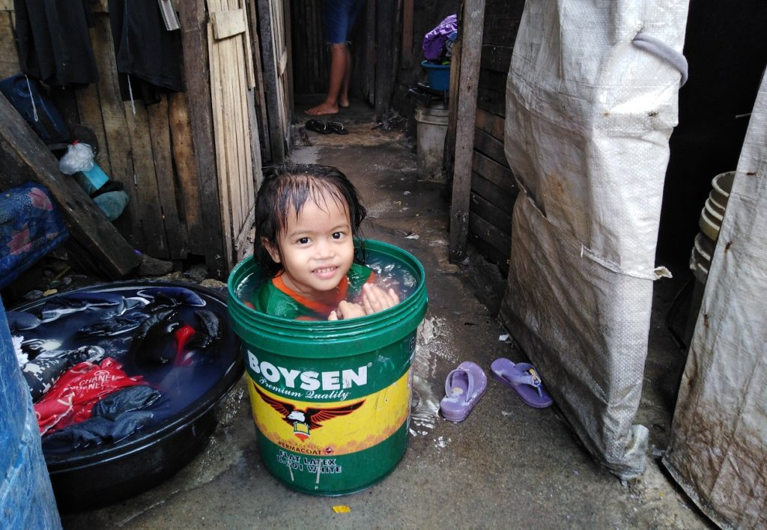
Bath time!
When we arrived in the Philippines in September, we noticed that good friends from back then started a new "Church so Blessed" church very close to us. We have been visiting the church there regularly since October last year. From the very beginning they were very interested in what we are doing with the "poor". We experience that they would very much like to support the poor, but don't really know how. Too much the worlds are separated from each other.
Finally they came to visit us at home in our squatter area. They were so moved how we live and about the relationships we have with the poor, that they decided to support us. So they made it possible for us to supply our children with notebooks at the beginning of school. A friend from this church would like to come to us regularly and help us with children. We are very happy about that! For my wife and me it is an important concern to bring these two worlds together and to make friendship possible. And who knows, what can grow out of these tender beginnings? We are excited!
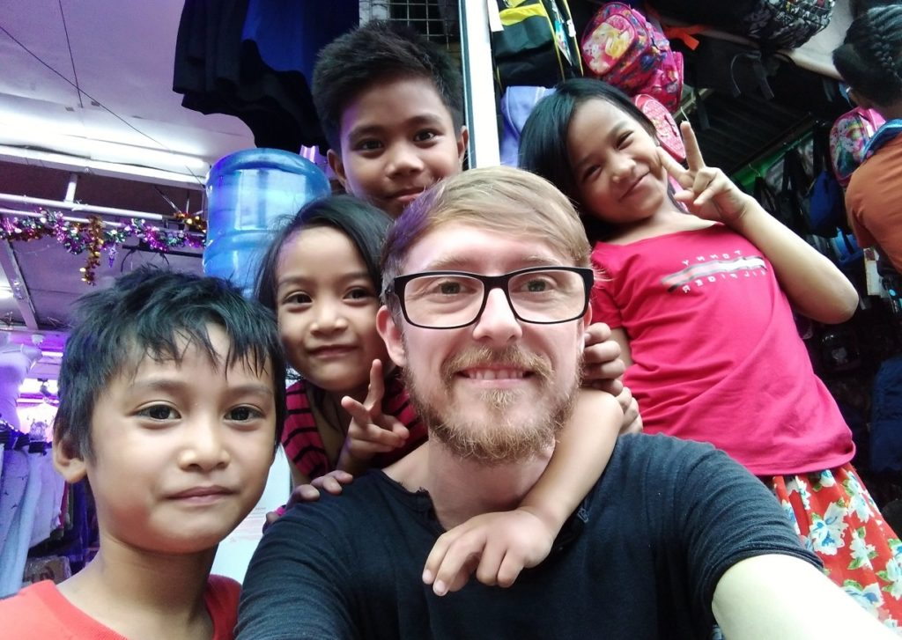

Metadata
count | 2
zn_page_layout | default
zn_sidebar_select | default
zn_show_social | default
zn_zn_disable_subheader
zn_subheader_style | zn_def_header_style
zn-custom-layout | 0
zn_page_builder_status

