A Rich Season Comes To A Close
Author | Jason Porterfield
Date | 2018-11-07 09:21:34
Categories | Articles India X Uncategorized
In September 2018, the last members left the city for good and, after 18 years, the Kolkata team dissolved. While being a little sad that it’s over, it seems good for us at times like this to celebrate the wonderful thing that the ‘K Team’ and their friends have brought to this incredible city. Most of the initiatives that have been begun over the years are now continuing under local leadership. The first team began in August 2000 with Sal & Gregg (with baby Toby). After marrying in New Zealand they did their ‘training’ by living in a Bengali speaking slum in Delhi, enjoying the friendship of the (still new) Delhi team. Since then there have been many chapters of life for the team, with 21 adults and 5 children being part of the group over 18 years. In the early years they were a small team, and remained strongly engaged with the people in their own neighbourhoods, while also joining with local Christians to respond to the poverty and injustice they witnessed. After a year or so, Marcus and Katharina (and later with baby Timon) joined from Switzerland. During their 7 years they helped establish Connexions, an innovative ministry amongst young women from the slums. As well as being trained in tailoring and paper crafts, the women were taught English, business skills and values for life. Today the project is directed by an Indian Christian ministry that continues to empower the women to earn a livelihood, grow in self esteem and dignity, and become self sufficient. Towards the end of Marcus & Katharina’s season, Kate, Jenny and then Jo joined the team. For several years they were deeply involved in some local churches and also a network of local Christians seeking to respond to poverty in their city. In 2010, a bigger team all arrived together, after doing their initial language learning in Bangladesh. Starting with Kenny, David, Meghan, Lois, and Steve & Jane (with Miriam and Henry in wide-eyed tow). They were joined over the next couple of years by Pete & Pip (manning the Team Centre), Cheri, Luke & Elisabeth (later with baby Nora) and Lisa. After exploring the whole city they settled in an outlying area sprinkled with many small slum communities. Team members lived in ones and twos in various neighbourhoods, mostly within walking distance of each other. They partnered with local churches and other groups, practised contextualised spirituality, built relationships with their neighbours and nurtured a strong close-knit community with each other. The creative energy of the team overflowed into several small social enterprises that address gender inequality, dangerous household pollution, and unemployment of women. Local people were trained and employed in (for example) jewellery making, sewing reusable menstrual pads, and assisting families to switch from smoke-producing cooking stoves to safer and cheaper options. Cheri also spent time at the local l’Arche community - communities of people with or without intellectual disabilities. Finally, Ben & Naomi arrived in 2016. They used their skills and previous training to volunteer with other groups: mentoring social workers at a drop-in centre for women in the sex trade, and assisting with the business side of a large social enterprise employing women who have left the trade. The honour-role below shows all the people who were the Kolkata team over the years. For some of them, you can click beside their names to read their own reflections on their years in Kolkata and some photos. As you read the brief stories and reflections, join us in praising our heavenly Father for the myriad ways the “Good News of the Kingdom” has been shared in this city over many years. May the seeds planted sprout, grow and bear fruit. "In the same way, let your good deeds shine out for all to see, so that everyone will praise your heavenly Father." ~ Matt 5:16 (NLT) Cathy(Servants International Coordinator) The Kolkata team 2000 - 2018
- 2000 - 2001 Sal & Gregg (with Toby) (for Sal’s reflection click here)
- 2001 - 2007 Marcus & Katharina (with Timon) (for Katharina’s reflection click here)
- 2006 - 2011 Kate
- 2006 - 2009 Jenny
- 2008 - 2010 Jo
- 2010 - 2014 Kenny
- 2010 - 2015 Steve & Jane (with Miriam & Henry) (for Jane’s reflection click here)
- 2010 - 2015 David
- 2010 - 2013 Lois (for Lois’ reflection click here)
- 2010 - 2011 Peter & Pip
- 2012 - 2017 Cheri
- 2010 - 2017 Meghan
- 2012 - 2015 Luke & Elisabeth (with Nora)
- 2014 - 2014 Lisa
- 2016 - 2018 Ben & Naomi
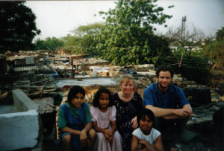
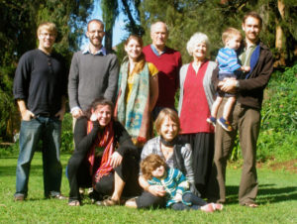
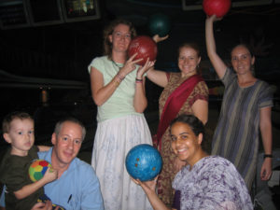
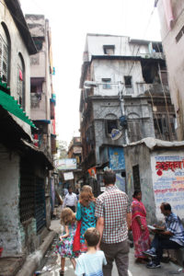
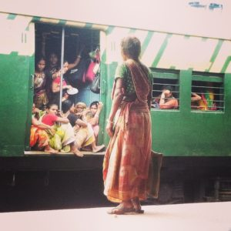
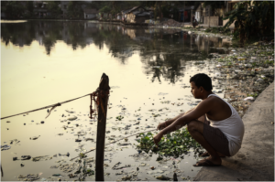

Metadata
zn_page_layout | default
zn_sidebar_select | default
zn_show_social | default
zn_zn_disable_subheader
zn_subheader_style | zn_def_header_style
zn-custom-layout | 0
zn_page_builder_status | enabled
zn_page_override_boxed_layout | def
zn_page_title_show | yes
zn_page_title
zn_page_subtitle
zn_page_builder_els | Array
show_header
show_footer
zn_page_custom_css
zn_page_custom_js

