A prayer for the tired, angry ones
Author | C Dee
Date | 2021-08-19 01:36:01
Categories | Articles Stories
This prayer written by Laura Jean Truman is from the book "A Rhythm of Prayer". The photos are from Cambodia.
God, We’re so tired.
We want to do justice, but the work feels endless, and the results look so small in our exhausted hands.
We want to love mercy, but our enemies are relentless, and it feels like foolishness to prioritise gentleness in this unbelievably cruel world.
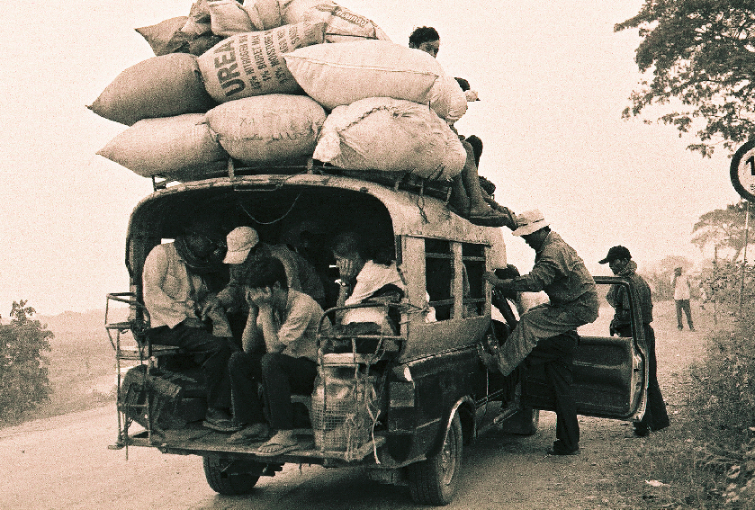
We want to w18alk humbly, but self-promotion is seductive, and we are afraid that if we don’t look after ourselves, no one else will.
We want to be kind, but our anger feels insatiable.
Jesus, in this never-ending wilderness, come to us and grant us grace.
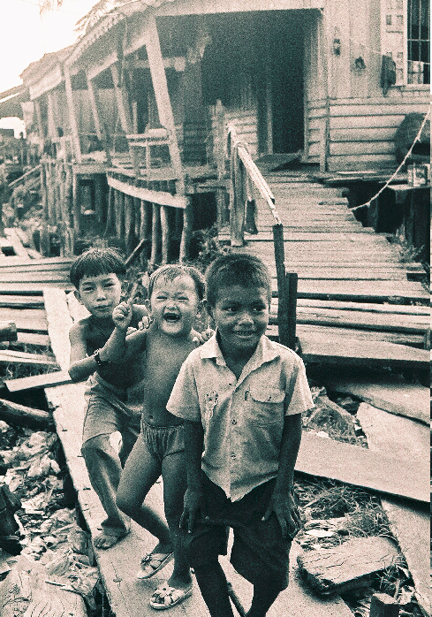
Grant us the courage to keep showing up to impossible battles, trusting that it is our commitment to faithfulness, and not our obsession with results, that will bring in Your shalom.
Grant us the vulnerability to risk loving our difficult and complicated neighbour, rejecting the lie that some people are made more in the image of God than others.
Grant us the humility of a de-centred but Beloved self.
As we continue to take the single step that is in front of us, Jesus, keep us from becoming what we are called to transform.
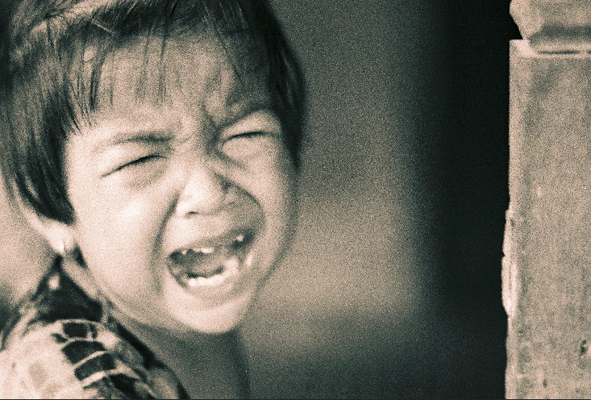
Protect us from using the empire’s violence—in our words, in our theology, in our activism, and in our politics—for Your kingdom of peace.
Keep our anger from becoming meanness.
Keep our sorrow from collapsing into self-pity.

Keep our hearts soft enough to keep breaking.
Keep our outrage turned towards justice, not cruelty.
Remind us that all of this, every bit of it, is for love.
Keep us fiercely kind.
Amen.

Metadata
zn_page_layout | default
zn_sidebar_select | default
zn_show_social | default
zn_zn_disable_subheader
zn_subheader_style | zn_def_header_style
zn-custom-layout | 0

