A day in the slum
Author | C Dee
Date | 2021-11-30 02:23:57
Categories | Articles India Y Internships Stories

After a long wait for a visa, I a m finally living in a slum in India, waking to the Muezzin, praying on the roof-top, and ...
Reflection from Anas, currently visiting the team in India
I waited a long time for the visa to finally be able to fly to India. And here I am at last, in a medium-sized city of around 4 million. Living in a slum.

Sunrise
It's 6 o'clock, I'm sitting on the flat roof of our house and looking at the many houses in our slum. I love this time. Everything is still, the sun has not risen yet. In the distance I see billows of smoke or fog rising. Sometimes you can hear someone snoring, but otherwise it's just quiet. Because the year is slowly coming to an end, it is also getting colder here. Early in the day, the temperatures are now around 16 ° C.
Since we live on the first floor of the house, I have a good view from the roof. But I can't see very far, because there's lots of houses close by. Our slum is relatively large. About 8000 people live here. Almost all the houses are bathed in a beautiful red, because the small sheds have become brick houses over the course of about 30 years. It is still illegal because the government owns the property. So there is always the risk that the bulldozers will come and tear everything down.

Prayer
As I am still sitting on the roof, absorbed in prayer, I hear the melancholy, melancholy voice of the muezzin* calling to prayer from the loudspeakers of the mosque. And so slowly life comes into the houses. You can hear women sweeping the floor, whistling pots, or loud music from the neighbors. There is really no privacy here. You get everything from each other. Our neighbors are only separated by a thin curtain and we also share the toilet with those who live below us.
I am allowed to live here with Yusuf and Jeshan for the time being. They have been living here in this slum for over two years, and are committed to helping the people who live in slums in our city in various areas. Today I follow Yusuf on his tour through our slum. The last few days he has been out and about a lot and has not seen many of the people here for a long time. We don't walk far because after 50 meters we have reached the edge of our slum. The three-lane railway line runs along here. When I lie on my mattress, I hear the loud honking, which sounds like a steamer. The trains here mostly run very slowly and honk because we slum dwellers, but also cows, goats and dogs, frequent the tracks a lot. Unfortunately, people or animals often die in the process. Recently a goat was run over again and the remains of the dog are still there.
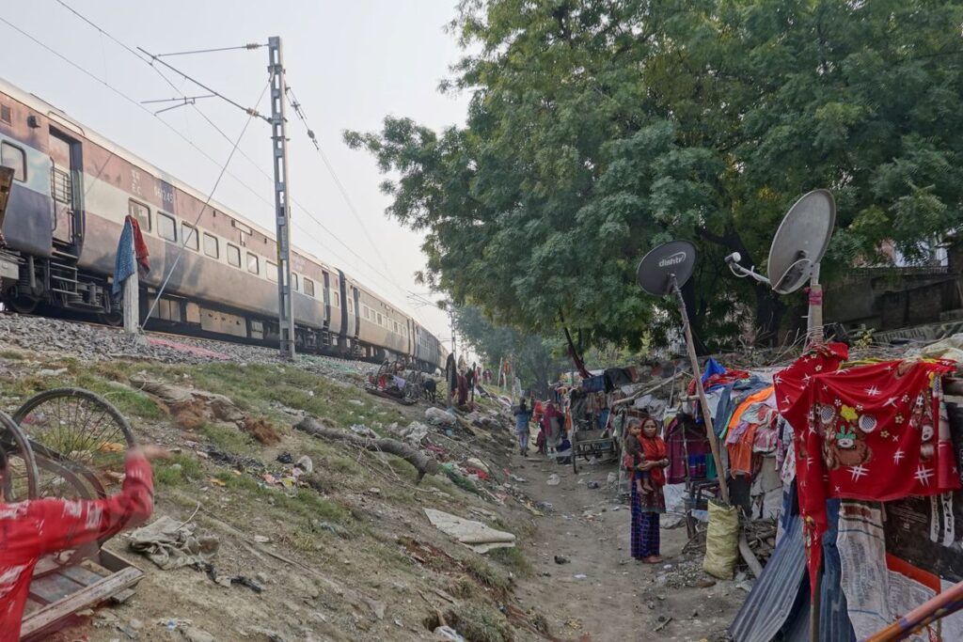

Trains, huts, and a baby
The huts are very simple right next to the tracks. Mostly they are just made of woven bamboo and large plastic sheets. This area of ​​the tracks was cleared earlier this year and all the huts were demolished. But in the meantime some of them have rebuilt simple sheds because they couldn't find any other place where they could live. Yusuf and I usually only walk a few meters because someone keeps shouting “Yusuf bhai” (Yusuf brother) and then a lot is said, sometimes weeping, asking for help or asking for advice. Again and again we are invited to the chai (which is very tasty here), but often refuse because otherwise they would spend money on it, which they could use better otherwise.
As we are sitting in the hut with a young woman (estimated to be 23 years old) and her newborn baby, a train thunders by and honks so loudly that I can hardly hear any more of the conversation - after all, the hut and the train are only a few meters apart. But I seem to be the only one who feels that way, because the conversation goes on as normal and the baby doesn't even twitch his eyes, but continues to sleep in peace. It's amazing how people can get used to their surroundings. Be it inhuman and unworthy of life, or full of luxury and comfort.

Hospitable space
Later we are invited to dinner by another family and sit for a long time in their 3x2 meter hut made of tarpaulin and bamboo sticks. In the hut there is actually only a 2x1.5 meter bed on which everything happens (live, cook, eat, sit, sleep, ...).
After we're back in our slum, I crawl under my mosquito net and hear the train pass again and honk before I fall asleep.
I am very grateful to God to be able to be here. It is not easy for people and yet they live, can laugh and do not give up. I can learn a lot from them.
* muezzin: the person who chants the call to prayer over loudspeakers at the mosque, at prayer time.

Metadata
zn_page_layout | default
zn_sidebar_select | default
zn_show_social | default
zn_zn_disable_subheader
zn_subheader_style | zn_def_header_style
zn-custom-layout | 0

