A Christmas Poem and Reflection
Author | Tom Dee
Date | 2021-12-25 23:44:33
Categories | Articles Poetry Stories

Expectantly Waiting
Centuries of our forefathers’ toil,
Enslaved then exiled on foreign soil.
Returning home, only to realise
The Pax Romana is full of lies.
Saddled by burdens – both large and small
God’s laws are good – but keeping them all?
How long must we wait? How long, Oh Lord?
‘Til you save from oppression and sword.
Today we look back, with long hindsight
We know how you came and set wrongs right.
Yet the night still is dark - hear the cries?
Bombs replace swords, but baby still dies.
The candle you lit flickers along
Yet we yearn for dawn when light blaze strong.
How long, oh Lord, how long must we wait?
‘Til you wipe each tear, make crooked straight?
When will the lamb lie with the lion?
Will ever peace reign true in Zion?
When will the needy receive their fill?
Will ever justice roll o’er each hill?
When will groaning creation give birth?
Will ever we stop pillaging the earth?
Must we keep waiting oh Lord… how long?
‘Til the world sings your redemption song.
Waiting’s not easy, any timescale
Keep our lamps burning, let not them pale.
For our wait is active – don’t you see?
Jesus is coming – let’s plant a tree.
For though heaven and earth will be new
It still matters right now what we do.
We will wait and prepare the stable
Work for kingdom, as best we’re able.
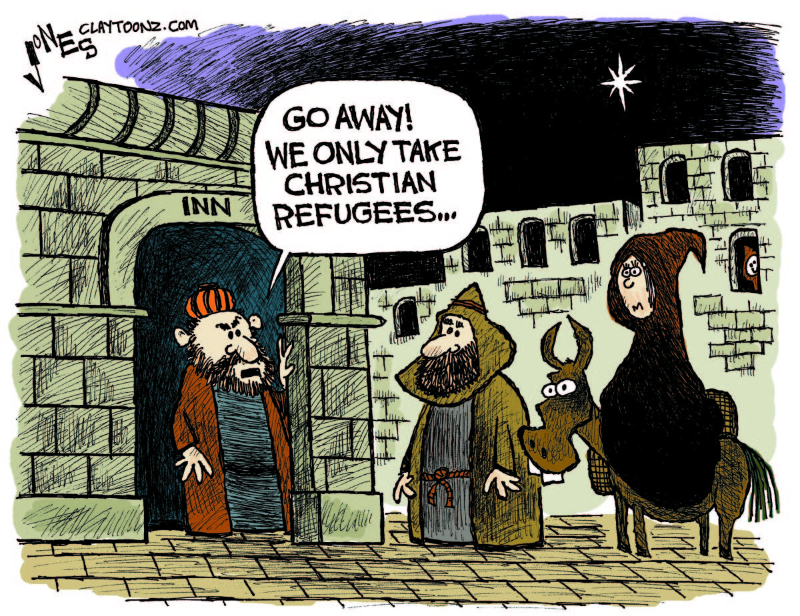

Reflection
This year I spent the last few days of advent on an epic journey to return to Australia. It involved a bus trip, a train, an autorickshaw ride, two flights, another train and a car – spanning four countries and 113 hours! In the limbo of airports and train stations, I waited expectantly (and sometimes anxiously) to be united with my family.
As I read Luke’s telling of the Christmas story, I noticed my situation had some parallels – deeper than just Mary and Joseph’s arduous journey to get to Bethlehem. The theme that stood out for me this year was active, expectant waiting – and God’s mysterious timing.
Zechariah had probably been waiting for a son much of his life. Probably, as he grew older, the expectant hope gradually shifted to a despairing one, and then likely slid into a somber acceptance of remaining fatherless. After all, if God had wanted him to have children, why would he make him wait so long? Zechariah doesn’t believe Gabriel’s improbable pronouncement that he will have a son, despite his old age. When rebuking Zechariah’s doubts, Gabriel says God’s words will come true ‘at their proper time’ (1.20).
God’s timing remains as mysterious today as it was then. Often only in retrospect can we look back and make out the shadow of God’s hand in how events unfolded.
While Zachariah had to wait long years for God’s timing, for young Mary God’s timing is unexpectedly soon. She’s not married yet – how can she become pregnant? It would have been so much less scandalous and more convenient for God to wait a year until after she was married to Joseph. But Mary is willing and delighted to go along with God’s plan, though it must have meant a lot of ridicule and vitriol directed at her.
In the temple courts, Simeon had been waiting to see the Messiah before he could die in peace (2.26). In the bigger picture, the Jews had been waiting for centuries for a Messiah to liberate them from oppression and occupation. They must have asked themselves why God was making them wait so long. For the Pharisees, the answer was that God was disappointed with the impurity of his people – and only once people followed the Law properly would the Messiah come. The Zealots, on the other hand, believed that God didn’t want them to wait any longer – they needed to attack Rome, and in the ensuing war, a Messiah would emerge.
In retrospect, it is easy to say that the Pharisees, the Zealots (and the Sadducees, Herodians etc) were hopelessly off the mark in their understanding of God’s plan, who the Messiah would be, and what he would come to achieve. But at least they were engaged in an active wait: their faith and their deeds were intertwined, they believed in a dynamism between human and divine action.
Today we also wait expectantly for Jesus’ second coming. With the groaning creation and the broken world, we also yearn for healing and wholeness. Like the Jews, we too struggle to understand why the wait is so long. But, like Mary and Simeon, let’s be patient in waiting expectantly for God’s timing (not our own). And, though it seems weird to say, let’s learn too from the Pharisees and the Zealots – God’s plan involves not our passive waiting, but our active participation, too. As NT Wright argues in his article ‘Jesus is Coming – Plant a Tree’ (a line I love so much I plagiarized for the above poem), what we do now matters to God’s plan for the future. Isaiah prophesies about ‘a new heaven and a new earth’ Jesus asks us to pray for God’s kingdom to come ‘on earth as it is in heaven’. So let’s wait patiently – and actively – for the Lord’s day to break forth.

Metadata
zn_page_layout | default
zn_sidebar_select | default
zn_show_social | default
zn_zn_disable_subheader
zn_subheader_style | zn_def_header_style
zn-custom-layout | 0
zn_page_builder_status | disabled

