April 2014
Sustaining Compassion:
Empathy

Discussion Sheet

Reading Resource
The Compassion Fatigue Workbook
Francoise Mathieu
Page 55: “Reduced ability to feel sympathy and empathy”

Internet Resource
You Tube: “RSA Shorts: The Power of Empathy”
https://www.youtube.com/watch?v=1Evwgu369Jw

Discussion Questions
- Most of you have taken the Myers-Briggs Personality Inventory. Do you remember how you scored on the Thinking-Feeling scale? If you ended up as a strong feeler you’re probably highly empathetic. If you lean toward being a strong thinker it’s likely that you’re less empathetic.

- Talk about how your level of empathy (high or low) impacts your effectiveness in your ministry.

- Hopefully you have a mix of really empathetic and less empathetic people on your team. How does your team benefit from that mix?

- Discuss with your team the things that led you to be part of Servants. How does your level of empathy influence the work you’ve chosen to do where you’ve chosen to do it?

- You’re probably familiar with the Enneagram and have talked about your results as a team in the past. How is your level of empathy reflected in your Enneagram type?

Scripture Reflection

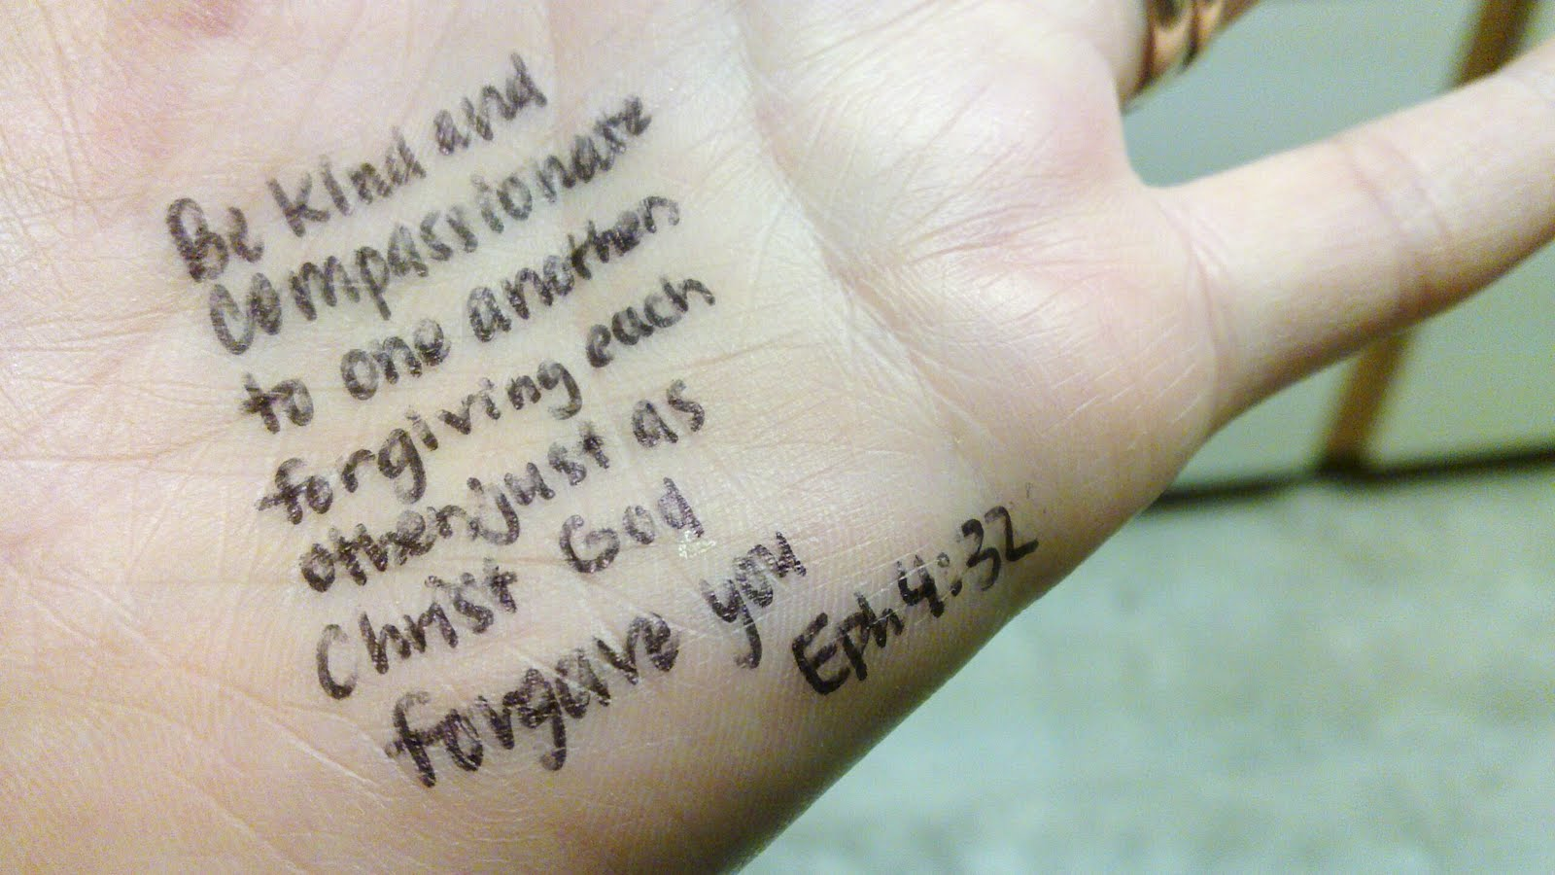

Contact info:
Martha Teater
martha@marthateater.com
828-734-6212

