March 2014
Sustaining Compassion:
Resilience

Discussion Sheet
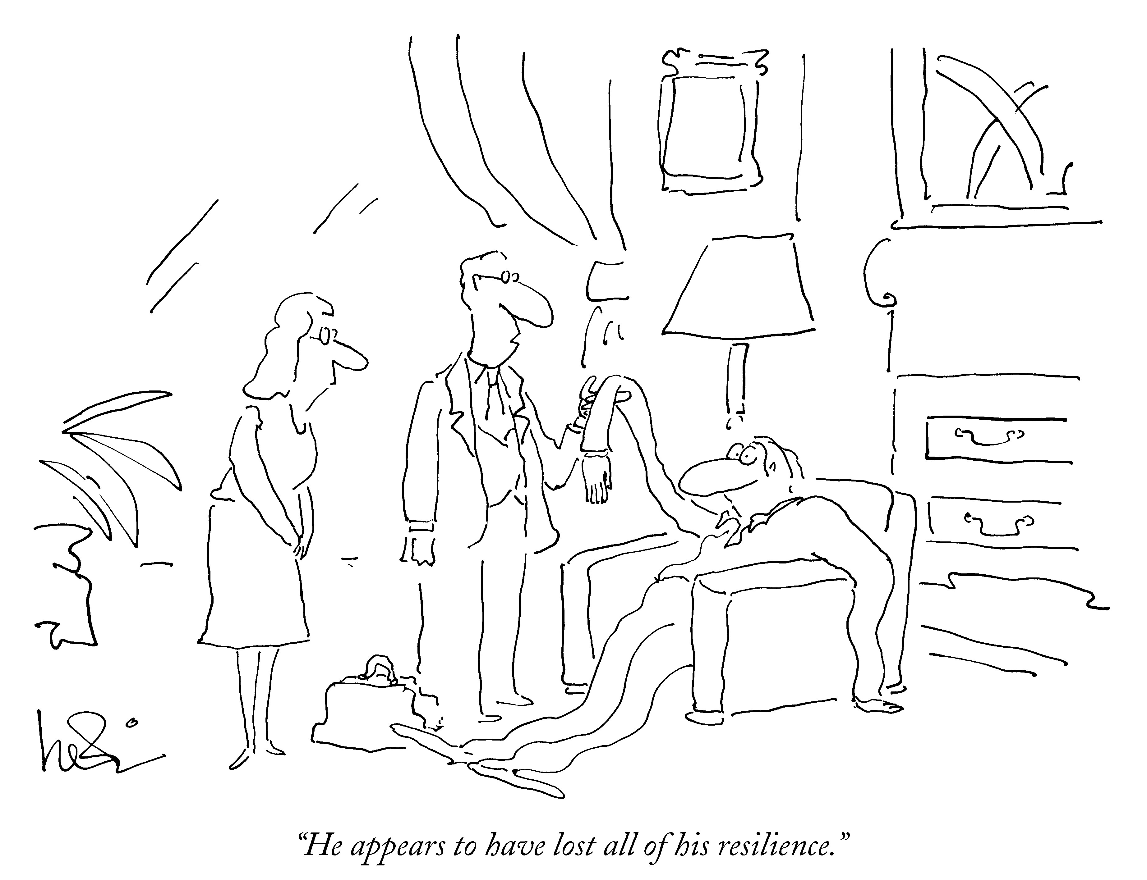

Reading Resource
The Compassion Fatigue Workbook
Francoise Mathieu
Chapter 14: Developing Compassion Fatigue Resiliency through Relaxation Training and Stress Reduction Techniques

Internet Resource
http://www.apa.org/helpcenter/road-resilience.aspx
This is a resource from the American Psychological Association on building resilience.

Discussion Questions
- Talk with your team about a stressful time in your life and how you got through it.

- As you think about that period in your life consider how you felt during that time and how you feel looking back on it. Can you see some resilience in how you handled that hard time?

- The outline has a list of things that can help people build their resilience. Pick out a few of those items that you would like to work on. Are there ways your team could support you in that?

- You live and work among struggling people with great needs. As you think about vicarious resilience, identify someone who has inspired you with how that person has handled stress, trauma, or hardship. How are you better for that?

- Being immersed in the suffering of others can lead to a lot of deep questions and spiritual struggles. Grappling with God to understand these things can be a real challenge. Talk with your team about how you can help each other look for the Lord in the midst of suffering.

Scripture Reflection



Contact info:
Martha Teater
martha@marthateater.com
828-734-6212

